Summer-Mae Wall
LL-000023418
Occupational Specialism

Feedback log for Greenfield Local Hub (GLH)

Contents
Table of Contents
Feedback log for Greenfield Local Hub (GLH) 1
Contents 1
User acceptance Criteria 2
Functional and Non-Functional Requirements 3
Functional Requirements (Business Needs) 4
Non-Functional Requirements (How the system should do things) 6
Key Performance Indicators (KPI) 7
Data Subjects (who data is collected from) 8
Non-technical 8
Technical 8
Form Design Log 8
Non-Technical Audiences 8
Planned Development points 9
Questionnaire Development 9
12
Observation Record Development 16
Scenario document development 17
Technical Audiences 19
Planned Development points 20
Feedback form Development 20
Overall Code Quality and Structure 22
Secure code programming principals 25
Database and database queries 28
Overall system 31
Feedback Report 35
Feedback Review 35
Non-Technical Audiences 35
Technical Audiences 44
User Groups 44
Overall Code Quality and Structure 45
Secure Coding Principals 50
Database and Database Queries 54
Overall System 61
Report Summary 66
Non-technical Audiences 66
Key Strengths 66
Areas For Improvement 66
Overview 67
Technical audiences 67
Key Strengths 67
Areas For Improvement 68
Rating Comparisons 69
Overview 69

User acceptance Criteria
no. | Criteria | How generated | Why important
1.1  1.2  1.3  1.4  1.5  1.6  1.7  1.8  1.9  2.1  2.2  2.3  2.4  2.5 | Clear navigation bar  Be able to see what products are available and see their ingredients  clear instructions on each page  fast loading times (2-5 seconds max)  alter orders  view orders  be able to select a delivery date and time  clearly see costs  be able to contact customer support easily  automated orders  product organisation  make staff accounts  limit what staff accounts can access  view orders to deliver/ collect | Research through alternative systems (see 12)  restaurant empathy maps (see 6)  following law (see 11) and alternative system research (see 12)  Research through alternative systems (see 12), NFR (see 9)  user stories (see 7)  user groups (see 5)  user stories (see 7)  Research through alternative systems (see 12)  user stories (see 7)  user stories (see 7), empathy maps (see 6)  user stories (see 7), Research through alternative systems (see 12)  user stories (see 7)  user stories (see 7)  empathy maps (see 6), user stories (see 7) | It is important so that users can easily understand and navigate the site.  To check allergens in products, following legislation on food regulations (see 1)  to make it easy for users to understand and reduce stress when using the system  fast loading times are needed to retain customer attention and to ensure the website looks professional  customers may change their mind on what they need to purchase and will want to have the ability to alter their order before it is delivered.  Users need to be able to see what they have ordered and ordered in the past so they can keep track of spending, what works for them, what doesn’t etc.  users need to be able to select a time that works for them for food to be delivered so that they can be there when it arrives.  Users need to be able to see how much products cost so that they can plan and buy products that match their budget  Users need to be able to contact customer support to report any issues they may have. Customers like good customer support that isn’t frustrating to work with.  Users may want the same food delivered on a set schedule (eg businesses). Automated repeat ordering can make this easier on them so they don’t have to waste time placing orders every time.  Products need to be organised in a meaningful way so that users can find them and know what they are purchasing.  Admin staff need to be the only accounts able to make staff accounts so that the system can’t be infiltrated and for UAC 2.4  staff should only be allowed to see data related to complete their jobs in line with GDPR (see 11) to protect the data of users.  It is also important to limit access to reduce confusion when using the staff system  staff need to be able to see who ordered what to package and deliver orders to the correct customer.

Functional and Non-Functional Requirements

Functional Requirements (Business Needs)
1. Customer Needs

no. | Criteria | How generated | Why important
1.1  1.2  1.3  1.4  1.5  1.6 | Users should be able to register and login to the system securely  Users need to be able place an order  Users need to be able to alter and delete orders  Users should be able to view their orders  users should be able to log out of their account  users should be able to view their account details | KPI’s (see 10), risks (see 13)  empathy maps (see 6)  User acceptance criteria (see 8)  user stories (see 7)  Decomposition (see 14)  law/ legislation/ guidelines (see 11) | To prove an increase in account creation (KPI 1.2, see 10), users need to be able to securely make and login to accounts. It needs to be secure to ensure that accounts are not intercepted or created by bots to prevent Denial of service (DOS) attacks.  Users need to be able to place an order for a product for the system to work effectively and sell products.  Users need to be able to add or remove items from their order before it ships out to fit their needs. (families/ households may change their mind on what they want to order)  Users should be able to view their order and its details so that they know what they have ordered and where/ when its coming to check all the information is correct and to verify the order has been placed successfully.  Users need to be able to log out of their account so that forms aren’t resubmitted (causing data to be duplicated in the database) and so accounts are kept secure.  Users need to be able to see their account details so they can be kept up to date. Ensuring the data isn’t redundant/ useless is important for security (passwords etc). It also helps ensure that the system is adhering to GDPR/ DPA 2018 (see 11).

2. Staff Needs

no. | Criteria | How generated | Why important
2.1  2.2  2.3  2.4 | Staff need to be able to login to the system securely  Admin staff need to be able to create accounts and set permissions  Staff need to be able to view orders  Staff need to be able to view and update stock | Risks (see 13)  laws (see 11), risks (see 13), User Stories (see 7)  empathy maps (see 6), risks (see 13), law (see 11)  empathy maps (see 6), risks (see 13), law (see 11) | Users need to be able to securely make and login to accounts. It needs to be secure to ensure that accounts are not intercepted and use to access data on customers (eg address) for malicious purposes.  Only admin staff being able to create staff accounts prevents random people signing up to the staff system and ensures that permissions are correctly set to fit the employees role so that they can only access what they need to for their job (e.g only accessing necessary data on customers to complete work)  Staff need to be able to view orders so that they can be packed correctly. Only staff members in charge of packing orders should be able to see the contents.  Staff in charge of keeping stock need to be able to see what they have received and update the system accordingly so that users can purchase it. Only users who should be updating stock should be able to, to prevent malicious misuse of the system so that the system is secure.

3. General Needs

no. | Criteria | How generated | Why important
3.1  3.2 | The website needs to be accessible and easy to navigate  The system needs to display information about each product clearly | Law (see 11), KPI 1.5 (see 10)  law (see 11), food standards (see 1), User stories (see 7) | The system needs to be accessible to all users under the equality act (see 11). It is best done by following WCAG guidelines to ensure that all users are considered. It is also important to retain customers as they will not become frustrated with the system and are more likely to choose it again.  The system needs to clearly state what a product is and its ingredients so customers are properly informed on what they are buying (protecting their right under the consumer rights act (see 11)), ensuring all products information and standards are up to date with food standards (see 1) and so customers are kept happy because they have received what they wanted when ordering.

Non-Functional Requirements (How the system should do things)
1. User Needs

no. | Criteria | How generated | Why important
1.1  1.2 | System needs to be easy to use  system should be able to run on a portable device | Research through alternative systems (see 12)  empathy maps (see 6) | The system needs to be understandable and easy to use so users choose it over alternative providers  system needs to be able to run on portable devices for staff who are delivering products (remote access) and users who are using the system on a portable device (ordering via a phone) as is the current norm

2. General Needs

no. | Criteria | How generated | Why important
2.1  2.2  2.3  2.4 | Passwords need to be hashed using sha256  Pages need to load in 2-5 seconds max  system should be adaptive to change.  system should have proper encryption when transporting data | Risks (see 13)  Research through alternative systems (see 12), UAC (see 8)  laws/ legislation/ guidelines (see 11), risks (see 13)  laws/ legislation/ guidelines (see 11), risks (see 13) | Passwords need to be hashed with an up to date hashing method (sha256) so that passwords are stored securely in the database  Pages need need to load in a timely matter to retain customer attention and ensure the website looks professional.  The system needs to be adaptable to changes in legislation and to meet the clients needs in the future. The system not being upgradeable makes it less efficient and unsuitable for long term usage.  The system needs to be secure, especially when handling data as per GDPR and to sustain trust with customers that their information is being stored securely.

Key Performance Indicators (KPI)

no. | Criteria | How generated | Why important
1.1  1.2  1.3  1.4  1.5  1.6  1.7  1.8 | Rise in sales  Increased User Account creation  increased orders  increased customer referrals  increased amount of repeat visitors/ customers  less security issues/breaches  increase in staff morale  loyalty rewards being claimed and used | Reviewing sales data  checking audit logs, seeing more accounts being added  reviewing sales data, checking audit logs, stock decreasing at a faster rate  referral programs, KPI 1.2  audit logs, KPI 1.3  risks (see 13)  staff feedback, amount of work done, staff retention  reviewing loyalty scheme data, user stories (see 7) | Seeing a rise in sales is crucial in rating the success of a new system because it shows that it is profitable.  An increase in account creation shows interest and use in the system by the consumer.  An increase in orders means an increase in sales, which proves that the system is profitable  customers referring each other to use the system proves that it is easy to use and like by consumers  customers returning to view and order more products. Shows trust and loyalty with the company and system being built.  Shows the system is up to date and secure to reduce the chances of a breach into the system. Keeping data secure as GDPR states (see 11)  staff’s happiness is crucial to a business. Happy staff work more efficiently and quickly to a high quality.  It also improves staff retention as unhappy staff leave to work elsewhere.  People claiming their loyalty rewards proves that they are using the system and are ordering repeatedly. This shows the system keeps customers engaged and loyal to the service.

Data Subjects (who data is collected from)

Non-technical
Data of non-technical users will be collected from students of my college and personal connections at home (eg parents, siblings etc). Data subjects will be instructed to not show bias based on their personal relationship with me. In a real environment, more anonymous subjects with no personal relation would be used to ensure the data shows no bias in their feedback.

Non-technical users will have the option to test the staff side of the system or the user side of the system. (see scenario document).

Technical
For technical feedback, A-level students and their teacher will be used to gather meaningful data on the technical side of the feedback needed.

Form Design Log
This log will be where I log the design process of the form that I will gather data from and the thinking process behind it.

Non-Technical Audiences

Non-technical Audiences will be testing how users react to a system. This will simulate users interacting with the system on the web.
They will not have access to the systems code and will only be able to interact with the database with features implemented in the code.
This feedback will help analyse how users react to the system, if the system works as intended with real users.

Planned Development points
Main focus on what data to gather:
- User interface Feedback
Gathering feedback on the user interface can help see how easy it is to use to a non-technical audience to see how well it met User requirements (see above) and find trends in how different groups of users (eg age groups) reacted to the user interface.
- User experience Feedback
Gathering feedback on the user experience can help dictate how non-technical audiences found using the system (eg what they liked, found easy to use, didn’t like, found difficult to use) and find trends between different user groups (eg age groups). This is also important to see if all the user requirements (see above) were met or if any user requirements were met.
- Observation of their system use
Observing how users react and navigate the system to see how users will use it (eg how easy is it to find what they want, what do they struggle to find and understand etc)
Best ways to gather data:
- Questionnaires
Questionnaires are an easy, understandable and reliable way to gather user data and hear what users thought of the system and see what users would like to see in future to improve the system.
Data gathered by the questionnaire can be used to generate graphs to make data east to read and understand what went well and what went wrong.
- Scenario document with observation record
A scenario document can be used to ensure the entire system is tested and feedback gathered on. It gives users something to do whilst on the system and guides them to try and use the system with purpose, rather then just randomly clicking around.
An Observation record can help document how users reacted to the system and what they did when using it to be turned into a report later on.

Questionnaire Development
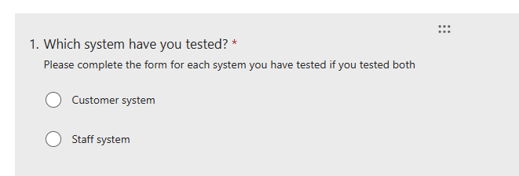

To not overwhelm the non-technical audience with different forms, I decided to make one form for both systems that is flexible to work for both systems. This choice box will be used for users to check off which system they have tested. If a user tested both, they are instructed to complete the form twice.

To start off I will asking users for their age group to separate them into user groups to use to analyse the data off of.

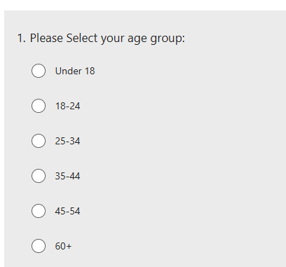

I am also asking for users genders (if they are willing to share) to help group them further. The system is more likely to be used by women as they are more likely to be the person in the household doing the food shopping for the household.
This means their opinions on how the system works, what it can do, how it looks etc is very valuable data that needs to be considered.
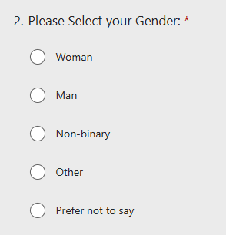

Starting off on questions about the GLH system after putting users into user groups, I asked users for their first impression of the website when they visited it so that I can see whats users are thinking when they first access the site.
This data is crucial as first impressions matter when it comes to websites, especially systems like GLH that stores user data.
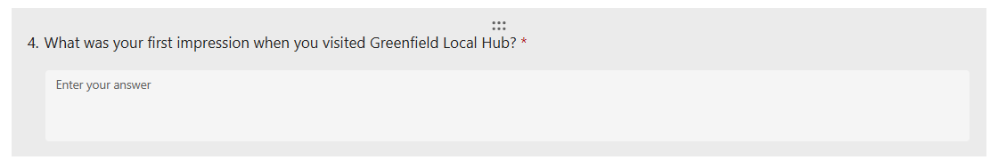

The next question asks the user to rate the overall design and layout of the GLH website with a simple star rating, this will generate numerical data to compare to see how users liked the general design of the website. This will offer insight on what users thought about it.
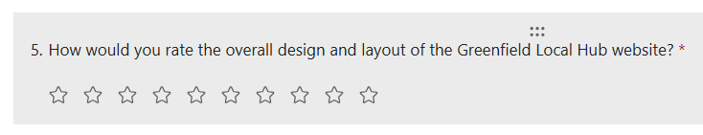
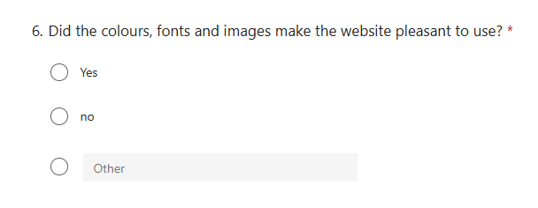
The next question continues on asking users about the appearance of the website, this time asking about the colour scheme, fonts and images chosen for the webpage. This is done to ensure that users enjoy how the website looks. This is really important as a users first impression of a website is how they determine if they want to engage with it.

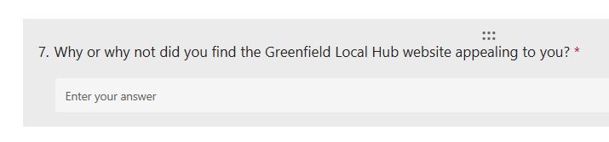
The next questions asks users why they did or did find appealing about the website to allow users to share their opinions on it. This will allow for users to share what they enjoyed or did not enjoy about GLH’s appearance which will help improve the websites appearance based on user feedback.
I included a likert scale for users to rate how much they agree with statements to gather data on how users found using the website without bombarding users with a large form which will deter them from completing the form.
I then included a test box below for users to add any extra details they feel the need to based on the statements provided.

Doing it this way saves time for the users so they are more likely to add more details into the text boxes in the form whilst still receiving a good amount of numerical data to use for analysis later on.

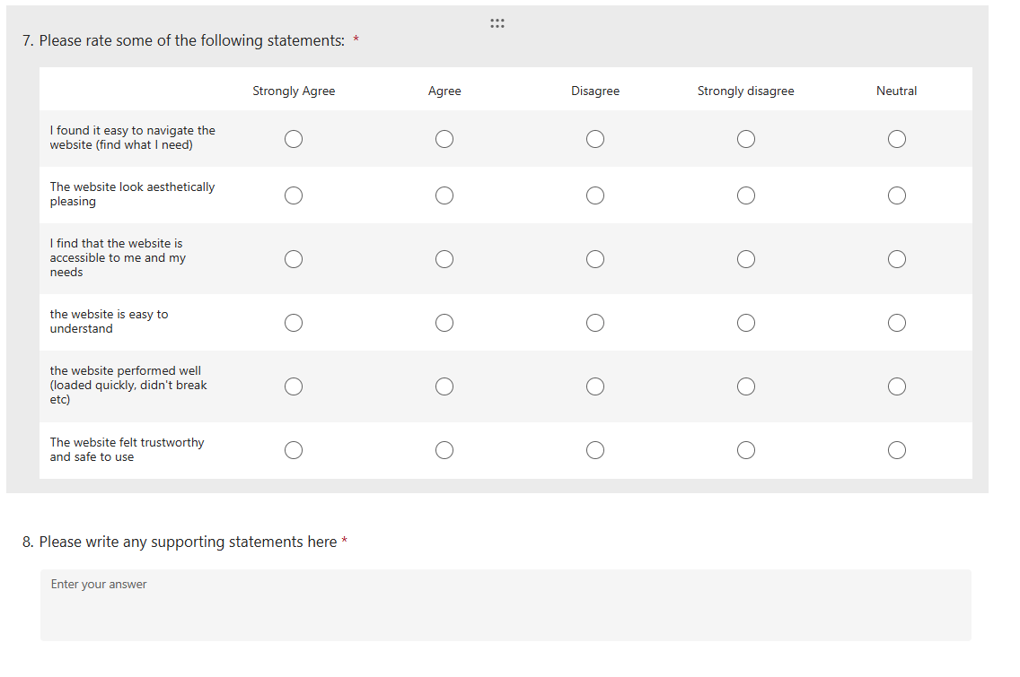
I made sure to add a question to ask if the website is accessible to meet users needs, this gives them a chance to express if the website meets their needs and is accessible to users with disabilities. (eg is the colour scheme good enough for colour blinds users, can users easily click boxes etc)

Asking disabled users to test websites for accessibility is important to make sure the website meets WCAG guidelines and works with how disabled users generally use them.

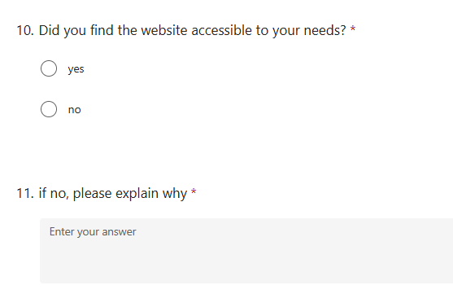

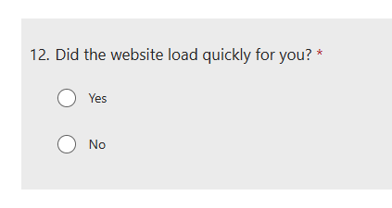
I added a question to ask if the website loaded quickly for users to make sure that the website met NFR 2.2. ensuring that pages load in a fast manner.
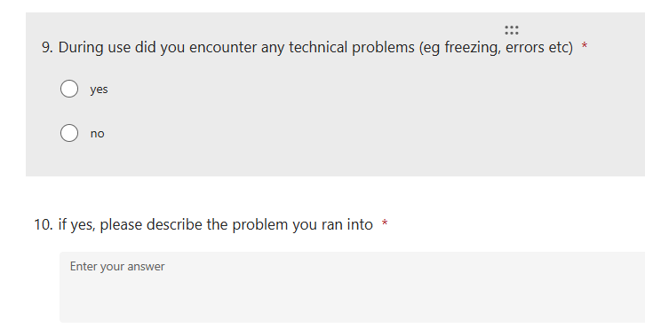
I chose to add a question for users to input if they encountered any technical problems during the development of the system to help make aware of any problems users are running into. This can not only help find patterns in where users encounter errors to predict their movements and needs out of the system but it can help find any unsolved errors left in the system. Closing backdoors and making the system more secure.

I decided to branch out and insert a ranking to change up from the linear form. Ensuring the user is thinking and is staying engaged with the form.
It shows what features they enjoyed the best and what they did not enjoy. This is useful for finding trends in what people did and did not enjoy using to see what users like and what needs improving to be more enjoyable for a user.
Like question 7, I added an option to write any statements to support their rankings so users have ample opportunity to express their opinions and also to inform parts of the system they did not test if needed. This will be informed to the user verbally if they need help.

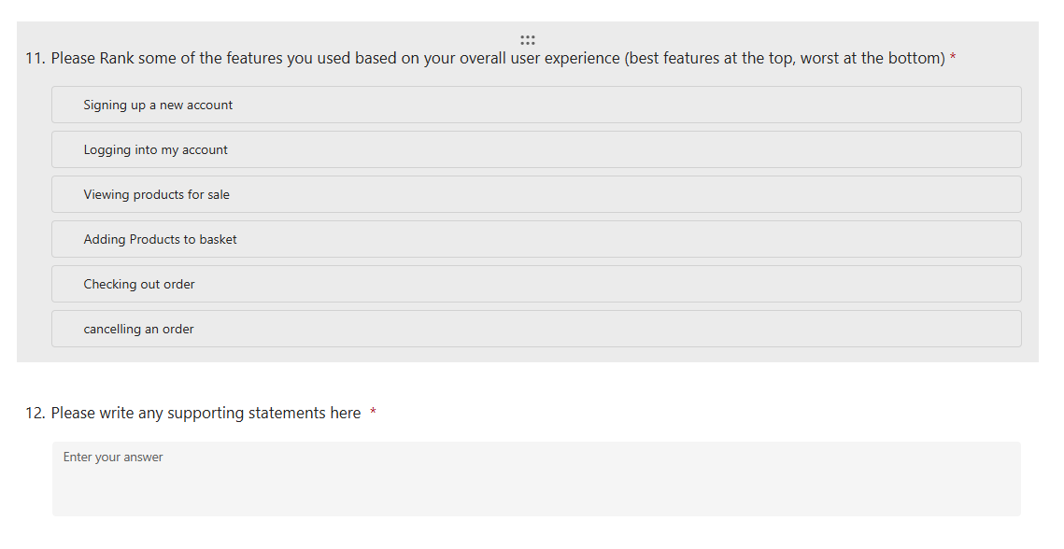
To gather some more numerical data, I added 2 ratings for users to complete about there likelihood to use the system and to recommend it to a friend. This can be used to generate graphs to show how people like and respond to the system. The data can be used to find trends in how much people are willing to use the system and recommend someone else to use it too.
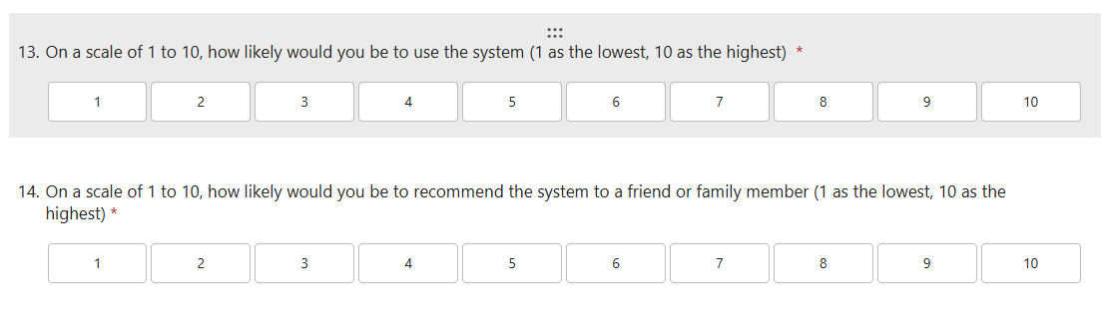
I added some questions to gather quantitive data about what a user thought about the system, gather what they like and what they would like improved. This data can be used to gather what works well and what users would like to happen to the system for it to improve.

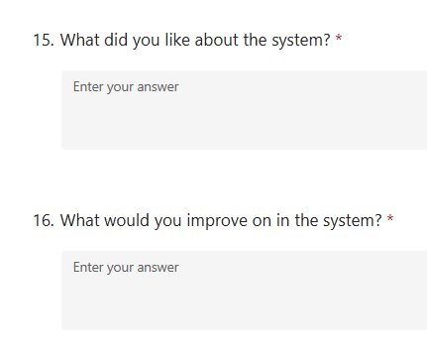

Finally, I finished with a simple question to ask what a user would rate the system out of 5 stars on a platform like trust pilot. This can help replicate how the site would do on a service rating site in it’s current state.

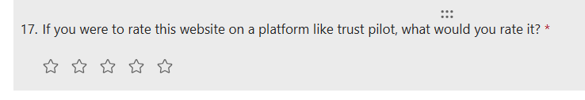

Observation Record Development
For the Observation record, I focused on 4 questions to answer when observing a user testing the system.
- What component is the user testing?
This allows for proper organisation of data to look for consistency/ patterns in user behaviour in different components.
- What did the user find easy to use?
This helps determine what users understand and found easy to use
- What did the user struggle to use?
This helps determine what users struggled to understand and may need revising
- Where did the user navigate the mouse to?
This helps determine what first grabbed a users attention when on the system and how they navigate the system

An additional column has been added for any important comments a user makes during the test

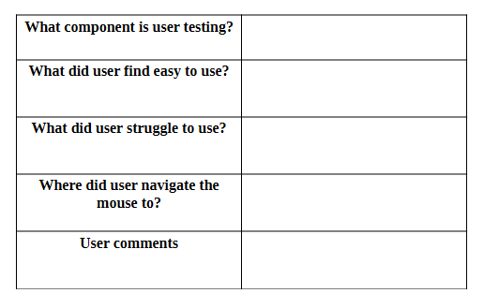
Above is a picture of how each single record is formatted for gathering data.

Scenario document development
For my scenario document, I decided to keep it simple and just explain what features there are to test and some details that the testers need to be aware of.
This is to make testing the system easier for non-technical audiences as this may be there first time testing a system and it helps make them aware of what they need to know before hand without contaminating the data collected
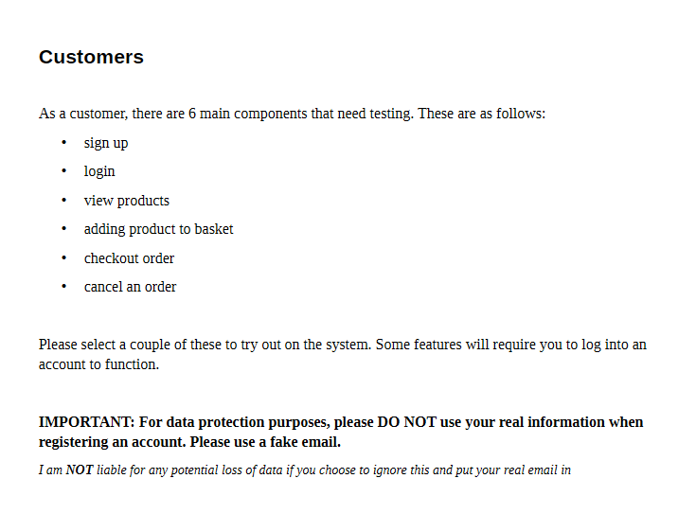
These have been separated for the customer and staff side of the system as they are separate from each other.

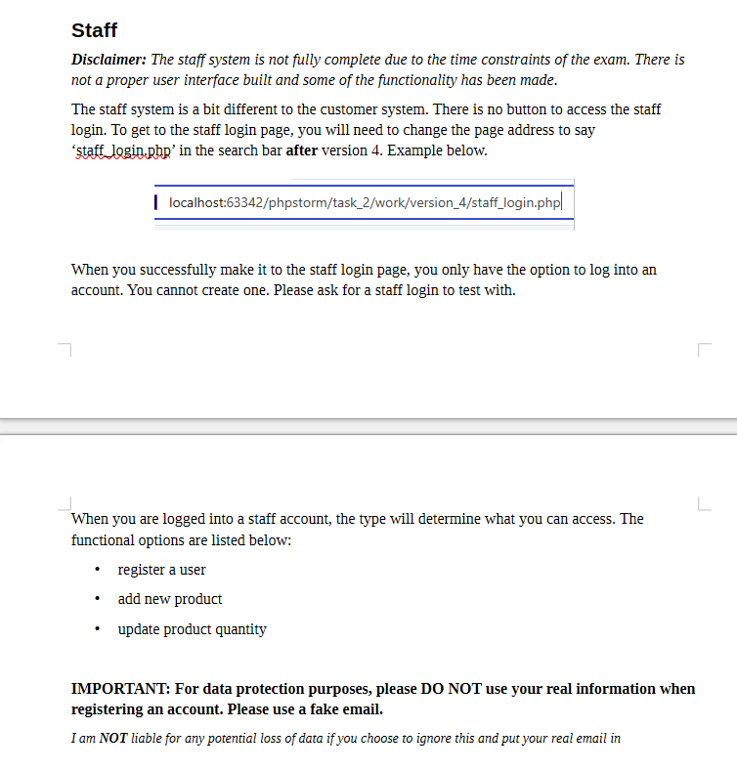
To ensure that user data is kept safe I placed a warning on each section to not use their real information when testing. Since they are testing a prototype I cannot guarantee that data is kept securely enough to meet legislation so to prevent a potential data leak of real data I added a warning. Put in bold to make it stand out so it is read.

I also added 2 sections, showing an existing account details for logging into staff and customer accounts in case users do not feel comfortable inserting data into the database for the customer and because it is needed to log into the staff account.

I also included some example fake email addresses (ai generated with ecosia ai for effiency) to use when registering accounts to the system. While I am gathering feedback, I will cross out ones that are used by testers.

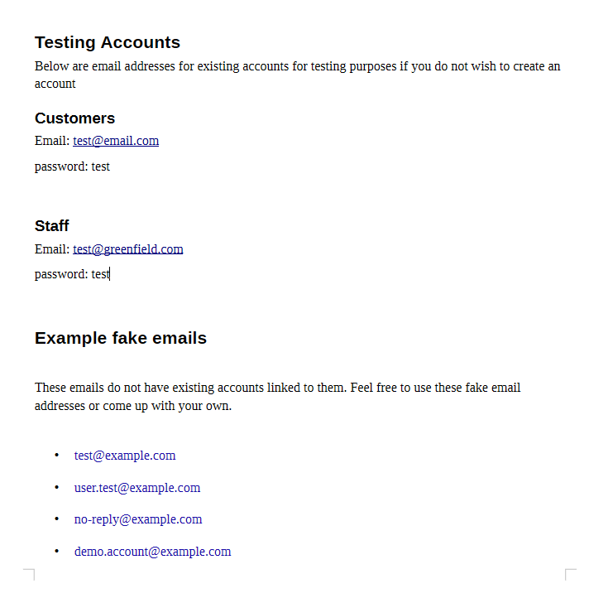

Technical Audiences

Technical Audiences will be reviewing the systems structure and code. They will review different parts of the code to ensure that it is understandable, secure and written efficiently. They will also offer some in sight on anything missed in the code, what be done better etc.
They will have access view the code and database but will not be able to make changes.
The feedback from technical audiences will help improve the code to be more secure and of higher quality and ensure that the code is maintainable, reusable and a long term use system for GLH.

Planned Development points
Main focus on what data to gather:
- Code Review of overall quality and structure
Users will review the code and review its quality and structure to ensure the code is good quality and is structured well. It can also be used to see where the code can improve for efficiency and improved security.
This will also help evaluate how readable and easy to understand the code (proper commenting, spacing of code, indentation etc) is to other developers/ technical audiences. (this is important for system maintainability, reusability etc)
- Code Review of secure Programming Principals
Users will review the codes programming principals to ensure it is up to date and secure to ensure the system will not be breached. This will help find any backdoors, faults or easy ways for people to infiltrate the system and protect user data, prevent the system from being abused (by breaching or abusing existing code to do something unintended) etc
- Review of database scheme and queries
Users will review the database and the queries into the database to ensure that data is being kept in the correct standard (as per legislation, proper security protocols etc).
Users will also review the queries that are interacting with the database to ensure that they work as intended, cannot be exploited or abused etc.
Best ways to gather data:
- Feedback form to gather ratings and comments on the system
A feedback form can be used to generate data on how the system performed and what other people thought of it to gather data on how to improve the system in different ways (eg security, efficiency, readability etc)

Feedback form Development

For the technical audience, I split the corm into sections so they are aware of what I want feedback on (overall code quality and structure, secure code programming principals, database and database queries and the overall system).

Since the technical feedback will be more insightful on what was done wrong or could be improved on within the system itself, I chose to include more questions to collect quantitive data where users write their opinions instead of numerical which will contribute more to graphs.

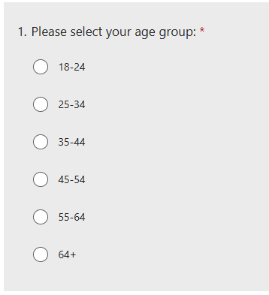
To start off the form, I chose to gather some data to put them into user groups. I started this off with getting age groups of users because older developers will have more experience and be more mature so they will be able to offer more insight on the code.

In a similar fashion, Ive asked for their highest level of relevant qualifications. This can help group users on how educated they are (in the typical education system) for more useful data then some of the younger users that will be reviewing the code. (a-level students)
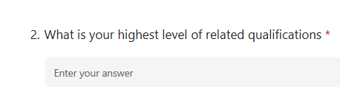

Finally, I asked users if they have experience reviewing code as those who have reviewed code in the past may know what to look out for compared to those who haven’t reviewed code before.
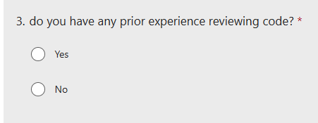

These questions will help group testers based on their age and experience reviewing code to see how people with different experiences.

Overall Code Quality and Structure
To start off, I did collect some numerical data by having users rate statements with on a likert scale to see what users generally liked in the system. The statements ask about the codes quality and allows users to rate on the codes quality.
The data gathered with the scale can help ensure that the non-functional requirements (see above) are met.
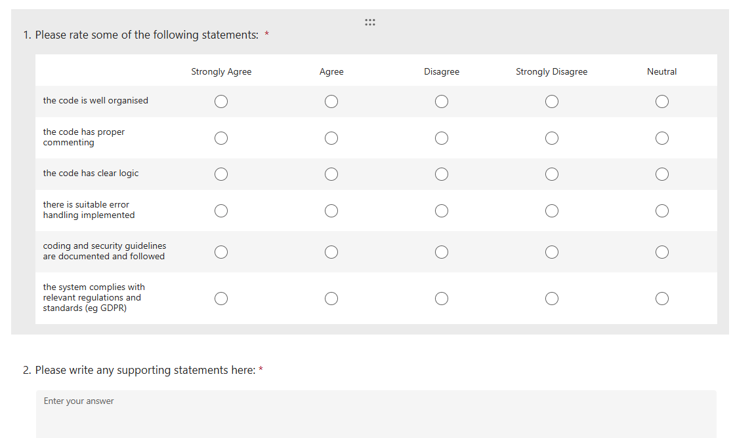
I asked if there were any code smells that users spotted during testing to ensure that large problems aren’t left unchecked or unnoticed with how the code is written. This will help improve how the code is written to avoid issues in the future

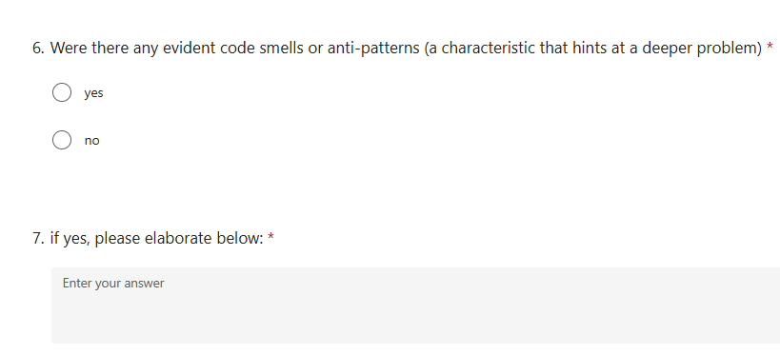
In the same theme as the last question, I asked users if they found any redundant or repeated code. This will help gather data on if there is anything unnecessary in my code with an option to elaborate so that users can explain where the issues are.
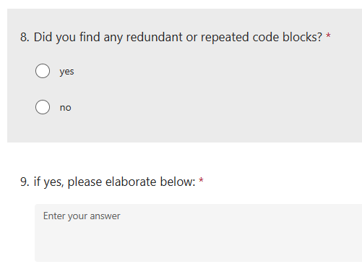

I asked for an overall rating to gather data on the overall opinion of the codes quality and structure to see the general opinion of it. This gives us an overall rating for the section which allows us to compare with other sections to see what needs the most attention for improvements.
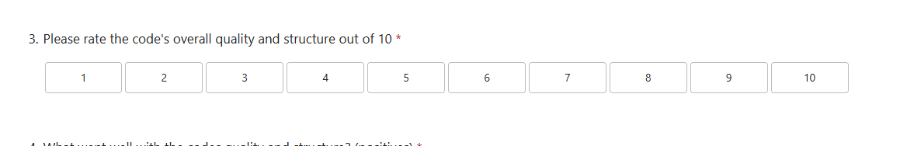
To finish off the section, I asked users for the positives and negatives of the codes quality and structure to gather quantitive data to analyse to see what went well and what needs improving.
This gives testers a chance to personally review what they liked, didn’t like and what they would improve on with the codes quality and structure.
The data gathered will be useful to see what things I could’ve missed and what stood out to users rather then having them ask a large amount of choice options that they will bore them.
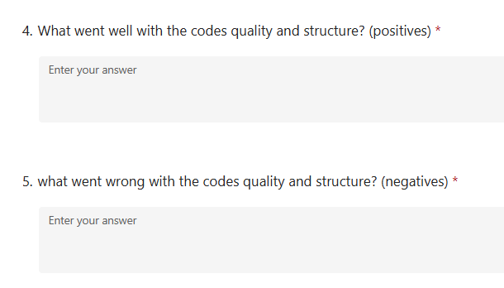

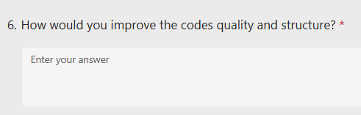

Secure code programming principals

I followed the same structure as I did with code quality and structure of starting off with a likert scale and then asking the user some questions to gather some quantitive data.
Users are asked to rate the systems security protocols (linking back to non-functional requirements) for the system to ensure that the system is compliant with legislation and guidance.
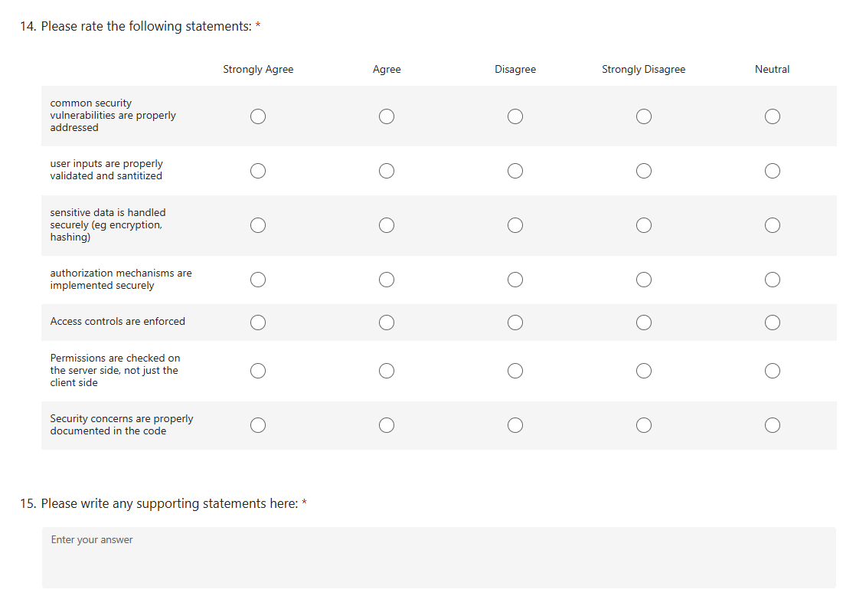

I asked users if the database credentials (passwords, usernames etc) to ensure their security. This will help determine how secure the database connection is so that it cannot be abused to gain access to the database.
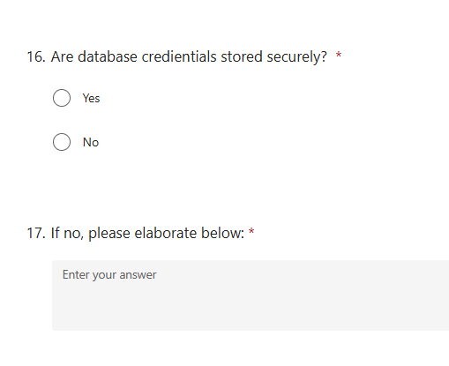
I asked to see if dependencies are up to date and vetted for security to ensure that anything added to the code externally is kept updated.

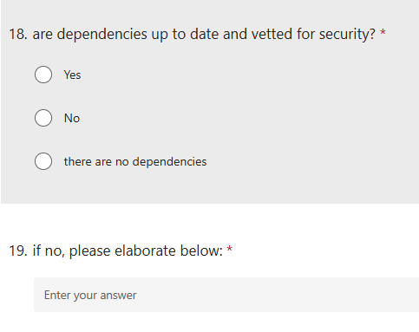

I again asked for a scale rating of the overall security of the code to analyse with different sections to find what users thought was the best and what users thought was the worse so that we know where to focus improvements on.
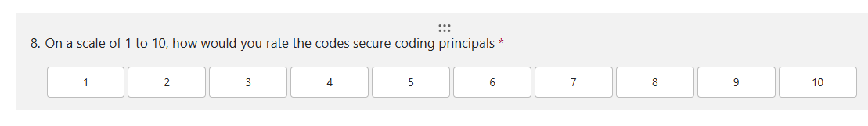
Like the last section, I asked users for the positives and negatives of the codes security protocols to gather quantitive data to analyse to see what went well and what needs improving.
This gives testers a chance to personally review what they liked, didn’t like and what they would improve on with the codes security protocols.
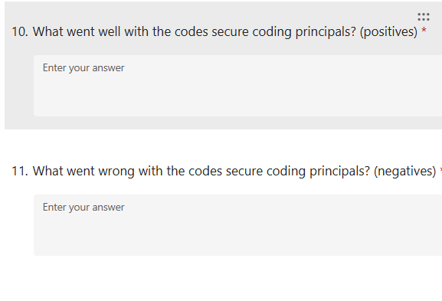
The data gathered will be useful to see what things I could’ve missed and what stood out to users.

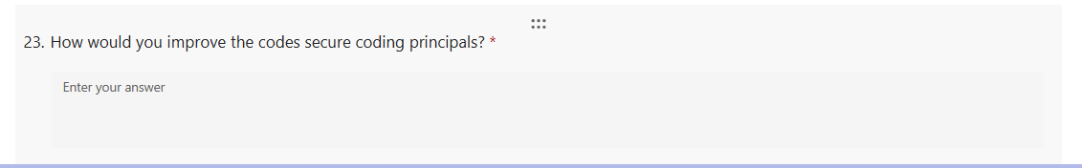

Database and database queries
For this section, I followed the same format as the other sections. likert scale for users to rate different components to meet the functional and non-functional requirements of the system.

For this section however, I separated the design and structure of the database from the queries are they are a little different. The data collected need to reflect on different bits as different sections of the database could perform differently depending on the quality of each component

For the first likert scale, I focused on the design and structure of the database, asking users to rate different factors shown below. This helps generate data on the database itself without complicating things by asking questions on the SQL queries at the same time.
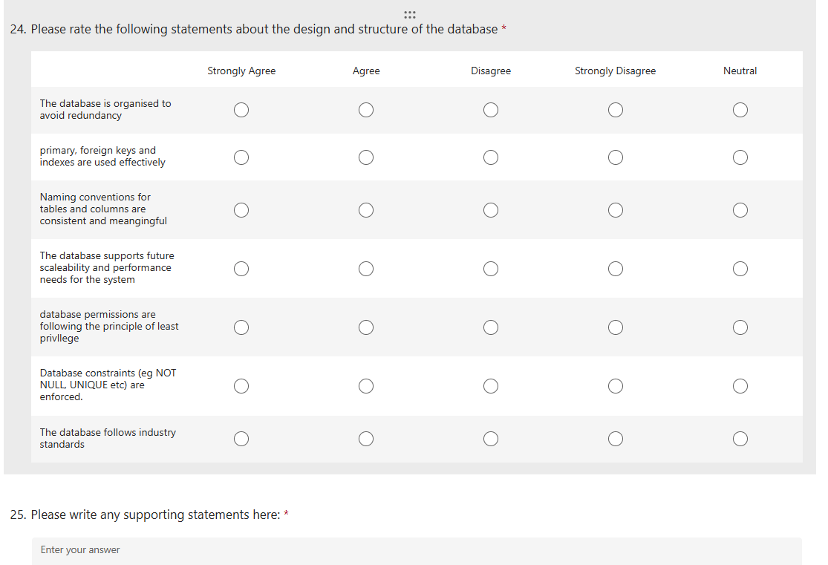
I again asked for a scale rating of the design and structure of the database to analyse with different sections to find what users thought was the best and what users thought was the worse so that we know where to focus improvements on.
For the same reasons as before, I separated this ranking from the queries so they can be analysed individually.
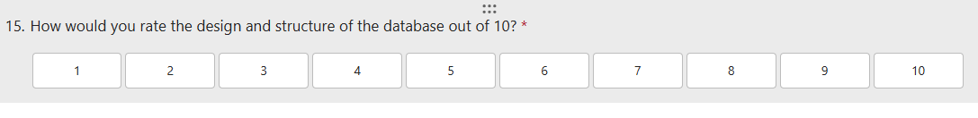
I asked users for the positives and negatives of the design and structure of the database to gather quantitive data to analyse to see what went well and what needs improving.
This gives testers a chance to personally review what they liked, didn’t like and what they would improve on with the design and structure of the database.
The data gathered will be useful to see what things I could’ve missed and what stood out to users rather then having them ask a large amount of choice options that they will bore them.

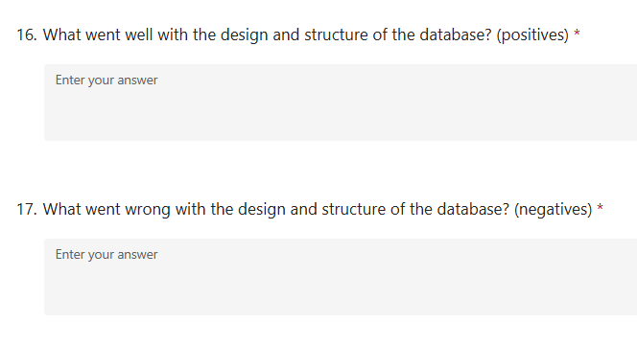
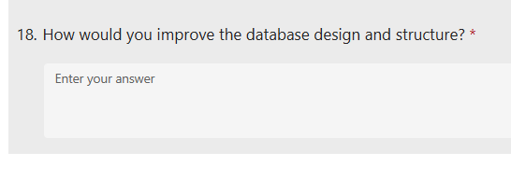

The second likert scale is about the queries to the database and the databases performance. This is to have the user rate the databases performance and security when interacting with it through the SQL queries.
The data gathered from this question helps ensure that the database is kept secure and queried in an effective way.
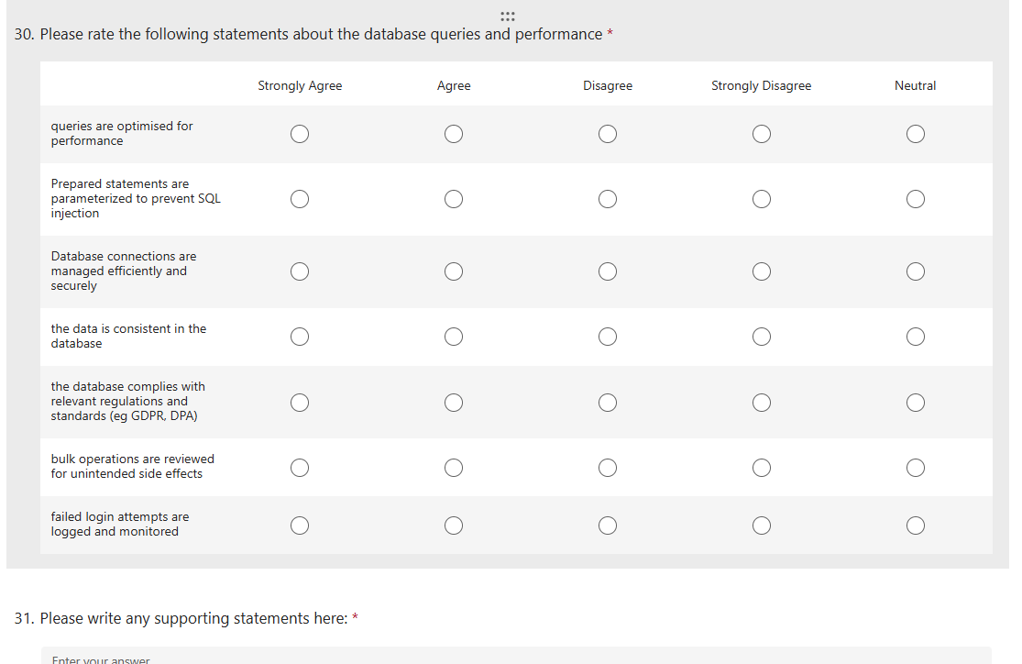

I again asked for a scale rating of the database queries and performance to analyse with different sections to find what users thought was the best and what users thought was the worse so that we know where to focus improvements on.
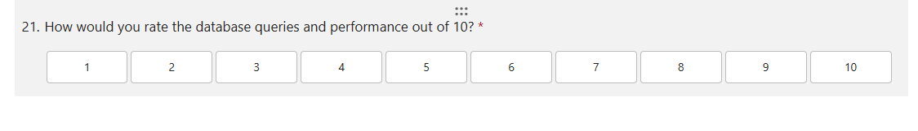
I asked users for the positives and negatives of the database queries and performance to gather quantitive data to analyse to see what went well and what needs improving.
This gives testers a chance to personally review what they liked, didn’t like and what they would improve on with the database queries and performance.
The data gathered will be useful to see what things I could’ve missed and what stood out to users rather then having them ask a large amount of choice options that they will bore them.
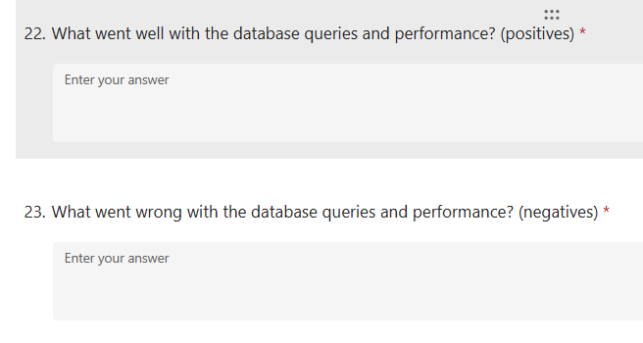
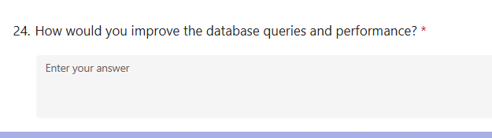

Overall system

For the final section, I made a section to analyse the overall system for any faults that occur in multiple places, bigger issues and issues that don’t fit the other sections. This gives the users a final chance to say anything about the system.

For the likert scale, I asked users to rate things that either didn’t apply to any of the sections or could be applied to all of them (eg proper version control). This makes a short but effective likert scale to ensure that all the non-functional requirements are met and considered.
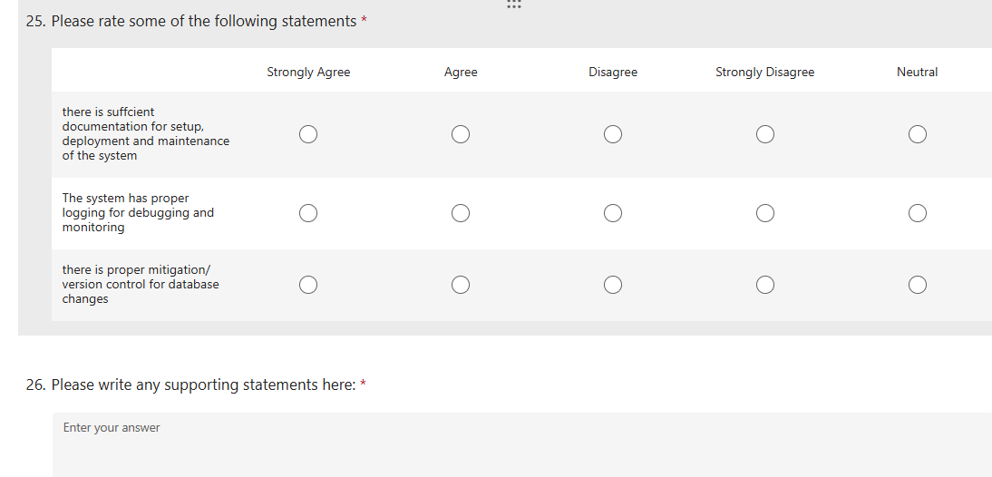
I asked for users general rating of the systems security to gather data on how secure it is as a whole so that it can be considered and to see if it needs reviewing before the website is deployed.
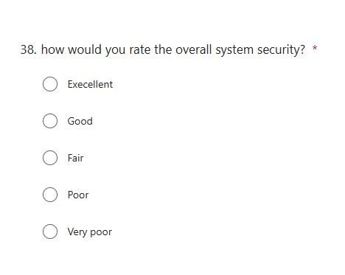

This question follows up the question on the systems security so that large security issues can be mitigated before they are used to breach or exploit the system.
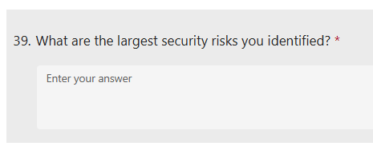

Following up with that will allow users to rate how confident the system is to attacks. This data can be used to see how confident testers are in the systems security so that it can be considered for future reviews before deployment.
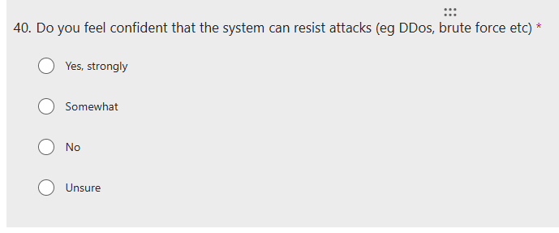
This allows testers to rate how usable the system is in its current state which will be crucial when it comes to reviewing if the system is ready for deployment or if it requires more time spent on it before it is deployed.
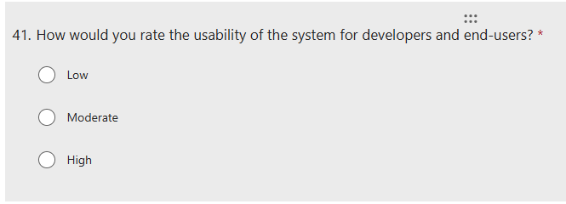
The next question asks users to rate how scaleable the system is. This data will be used to see if the current system is suitable for long term use, to be maintained and upgraded in future.
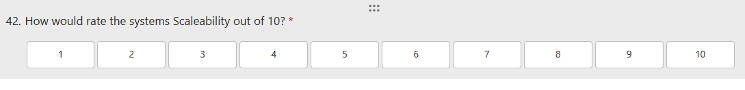
I asked users to rate the overall system. This separates from the other sections as the entire system can’t compare to each individual section. This will help give an overview of the general quality of the system.

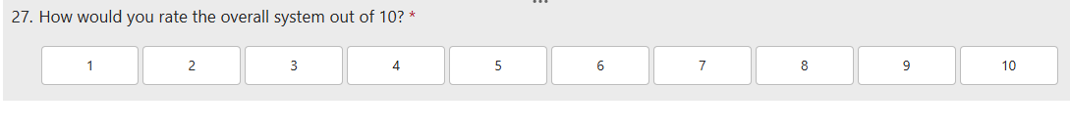
I asked users for the positives and negatives of the overall system to gather quantitive data to analyse to see what went well and what needs improving.
This gives testers a chance to personally review what they liked, didn’t like and what they would improve on with the overall system.
The data gathered will be useful to see what things I could’ve missed and what stood out to users rather then having them ask a large amount of choice options that they will bore them.

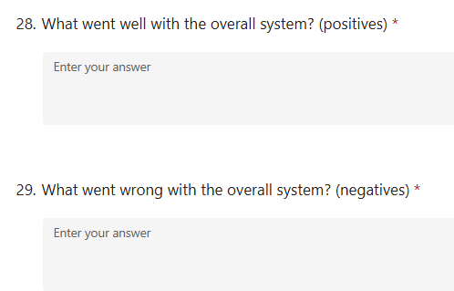
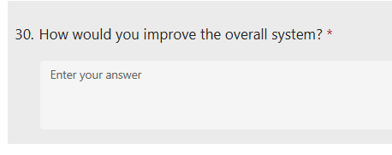

Feedback Report

Feedback Review

Non-Technical Audiences
Most of the users who completed the form were between 18-24, more on the younger range due the testers available being students. This is not the target age range but is all that was available.
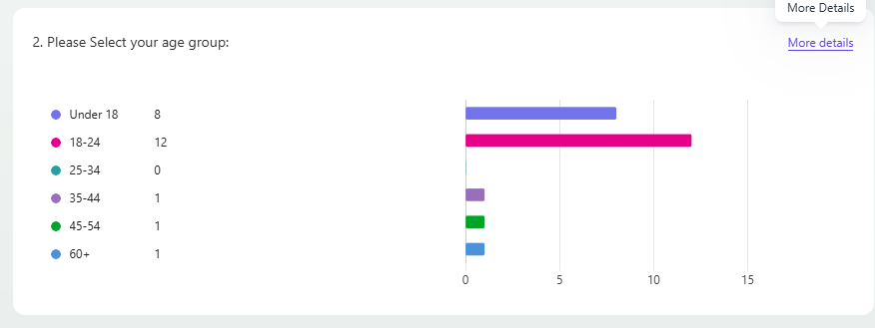
39% of testers were male. This is also not the target audience for the website as it is more intended to be used by women (30% of users). This is due to the testers available. In a real feedback environment, feedback would be gathered from those within the target audience.
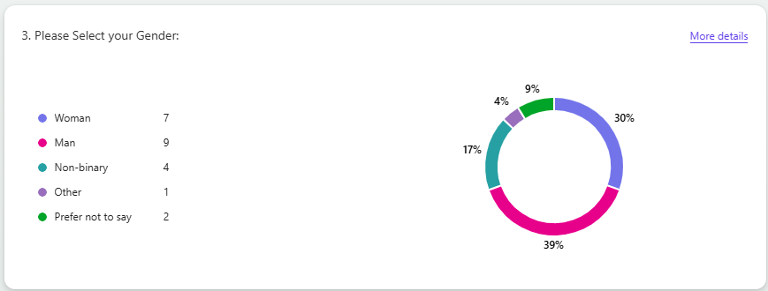

For question 4 (what was your first impression when you visited GLH?) users has a range of feedback. Some positive:
- very classically farmers market themed
- good
- impressive layout
etc and some negative:
- lots of blank space
- needs more colour and css
- no content
- bland
- looks unfinished
etc.
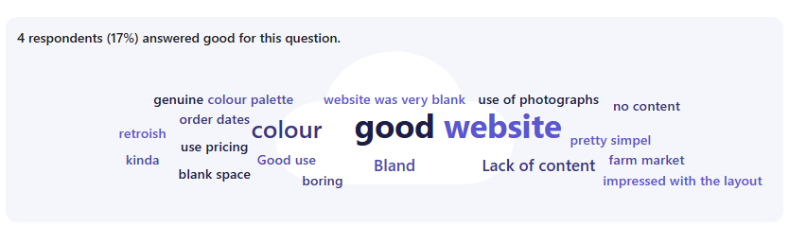

The rating of the general appearance has an average of 4.43 stars out of 10. This puts the rating quite low and indicates that the appearance needs work.
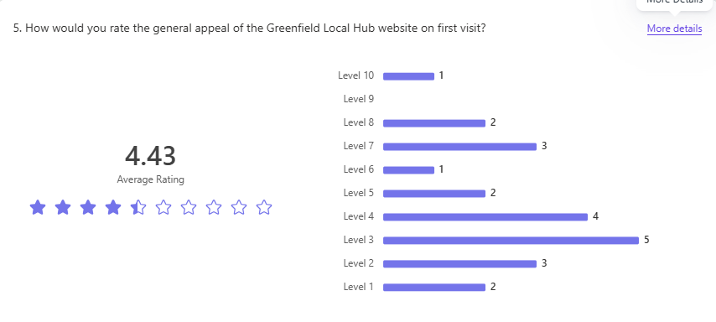

For question 4 (Why or why not did you find the GLH website appealing to you?) users has a range of feedback. Some positive:
- worked well and was functional
- liked the colour scheme
- you can order as much as you need
- easy to add quantity of items
- The green and beige is a nice combo
etc and some negative:
- Lots of empty space
- hard to navigate
- colour scheme is plain
- no content
- website is boring
- couldn’t tell what the website was supposed to be

The feedback was more negative then positive sharing that the website is plain, lifeless and boring. Making it uninteresting to a user.
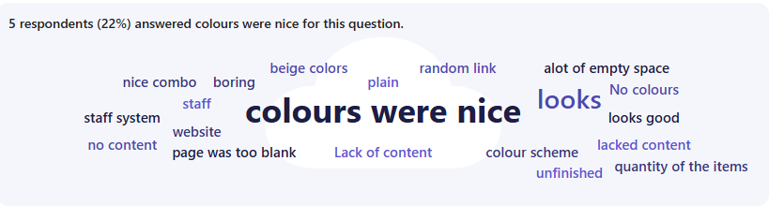

I found it easy to navigate the website (find what I need) -
47.8% of users chose strongly agree, 43.5% of users chose agree, 8.7% of users chose disagree.

91.3% of users agreed with the statement above, This shows that the website is easy to navigate.

The website look aesthetically pleasing – 30.4% of users chose strongly disagree, 21.7% of users chose strongly agree, 21.7% of users chose agree, 21.7% of users chose disagree, 4.3% of users chose neutral.

52.1% of users disagreed with the statement. Based on that and earlier answers the website is not aesthetically pleasing to most users.

I find that the website is accessible to me and my needs - 69.6% of users chose agree, 21.7% of users chose strongly agree, 4.3% of users chose disagree, 4.3% of users chose strongly disagree.

91.3% of users agreed with the statement above, showing the website was accessible to their needs.

the website is easy to understand – 43.5% of users chose agree, 39.1% of users chose strongly agree, 13% of users chose disagree, 4.3% of users chose strongly disagree.

82.6% of users agreed with the statement above. This means most users found the website easy to understand.

the website performed well (loaded quickly, didn't break etc) - 73.9% of users chose strongly agree, 8.7% of users chose agree, 8.7% of users chose strongly disagree, 4.3% of users chose disagree, 4.3% of users chose neutral.

82.6% of users agreed with the statement above. This means the website performed well for most users.

The website felt trustworthy and safe to use – 34.8% of users chose disagree, 26.1% of users chose strongly disagree, 13% of users chose strongly agree, 13% of users chose agree, 13% of users chose neutral.

60.9% of users disagreed with the statement above. This means most users did not find the website trustworthy or safe to use.
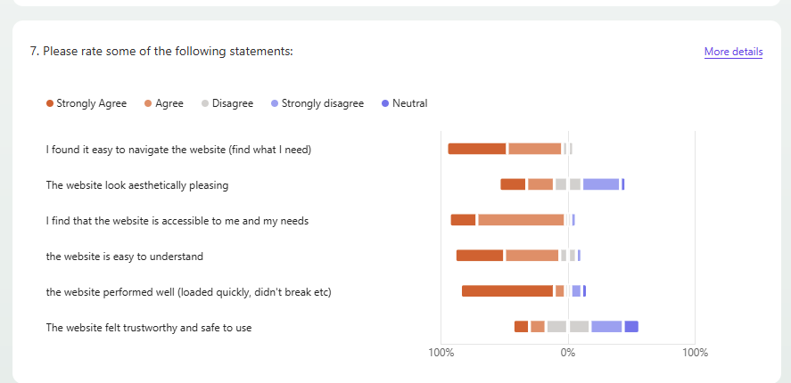

Users had a range of supporting statements. Some positive:
- liked how it showed images of the foods
- liked the colours
and some negative:
- 404 error when checking out
- website doesn’t look secure
- website doesn’t look appealing
- basket is not easy to find
- website looks suspicious
- didn’t know what the website was
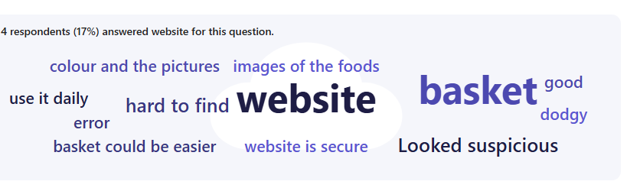

This shows that 70% of users ran into a technical problem when using the website
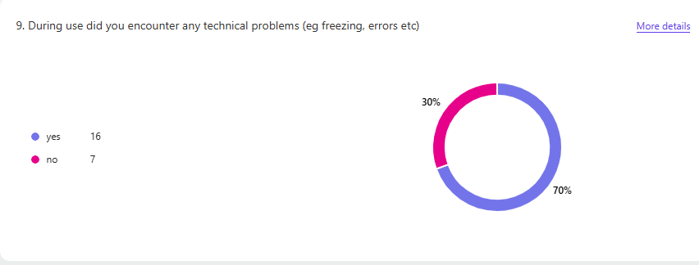
user described the issue as getting a 404 error when trying to checkout.
One user experienced issues with the footer blocking the bottom half of the page when trying to checkout.
Another experienced some issues when signing up and logging into an account.

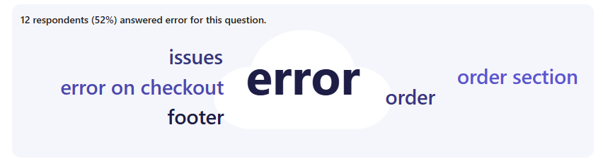

For ranking products. Users ranked products in the following order:
- viewing products for sale
- signing up to a new account
- adding products to basket
- logging into an account
- cancelling an order
- checking out an order
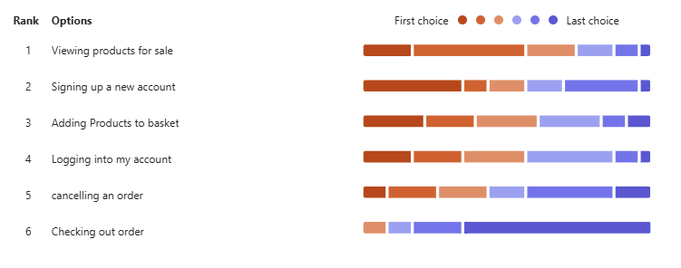
User had mised feedback to support this question.
Some finding processes like signing up annoying and finicky. Checkout did not work as intended and that viewing products was not done in an ideal manner.

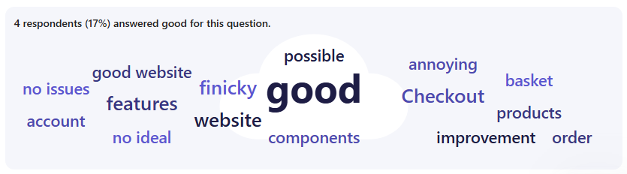

The average rating for how likely a user was to use the system was 5.52. This is just over half but not an ideal amount of willing users.
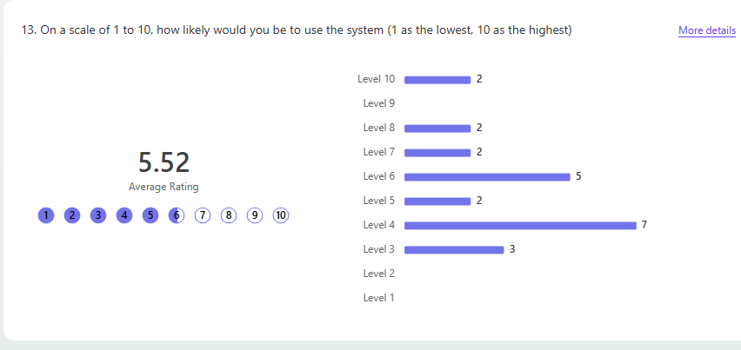

The average of users who would recommend the websites to friends and family is only 4.09. This a very low rating and proves that KPI 1.4 has failed to be met.
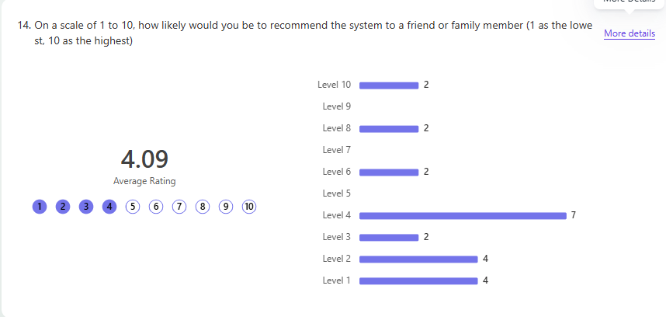

For question 19 (what did you like about the system?) Users had the following feedback:
- They liked that they could order everything
- they found the system east to navigate
- the like the descriptions and pictures of the food
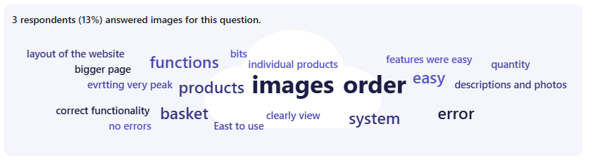
- enjoyed the functionality of the website

For question 20 (what did you improve on in the system?) Users had the following feedback:
- fixing the technical errors checking out
- improve the layout
- improve the styling
- make products line up next to each other, not just underneath
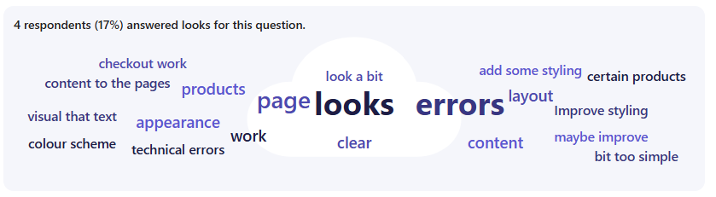
- make the website more clear

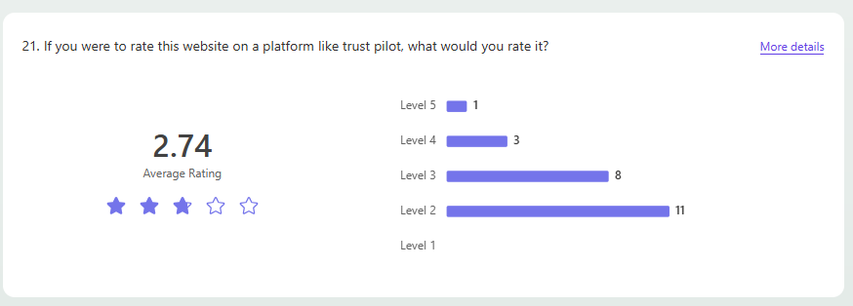
For the last question, the trust pilot rating is quite low, this shows that users believe the website is not trustworthy to users.

Technical Audiences

User Groups

To start off with user groups, I have skipped the data on age as every tester was in the 18-24 category (this is due to the testing group being students)

For qualification level, All only had low level qualifications (again due to the testers being students). Some choosing to right the qualifications they hold, some choosing what they are going to get and one user sharing their real world experience (see below).
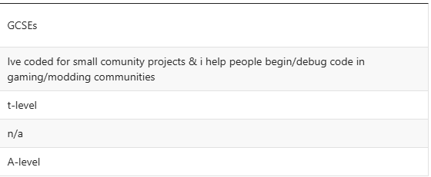

There was a 60-40 split in user experience reviewing code. A pretty close difference in whether testers had reviewed code before.
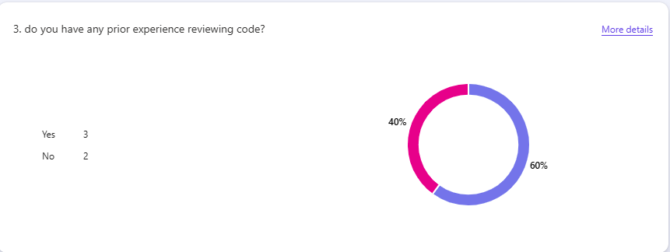

Overall Code Quality and Structure

This likert scale had pretty similar results for each question. Testers tended to vote the same way for each statement.

The code is well organised – 80% of users chose agree, 20% of users chose strongly agree.
This shows all all users agree that the code is well organised

The code has proper commenting – 80% of users chose agree, 20% of users chose strongly agree
This shows all users agree that the code has the appropriate amount of commenting.

The code has clear logic – 60% of users chose strongly agree, 20% of users chose agree, 20% of users chose disagree
This shows that most of the users (80%) agrees with the codes logic.

There is suitable error handling implemented – 60% of users chose disagree, 40% of users chose agree
This shows that most of the users (60%) disagrees with the statement, disagreeing that the code has suitable error handling in place.

Coding and security guidelines are documented and followed – 40% of users chose neutral, 20% of users chose agree, 20% of users chose disagree, 20% of users chose strongly disagree

Most users for this question chose neutral, This is most likely due to a lack of knowledge on security guidelines in the testing group.

The system complies with relevant regulations and standards (eg GDPR) - 80% of users chose disagree, 20% of users chose neutral

Most users disagreed that the code met relevant regulations and standards. This means most users don’t think that the code meets the proper regulations.
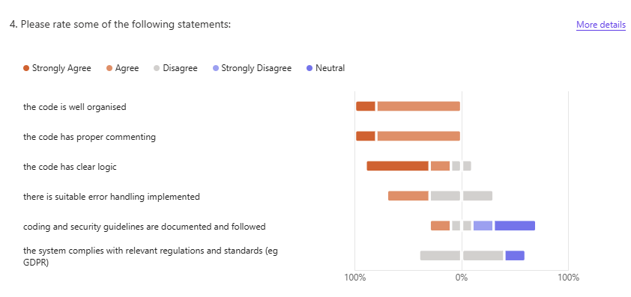
Note worthy statements for this section are seen below:
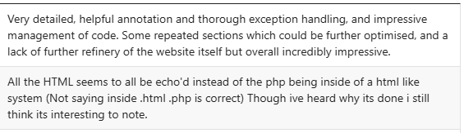

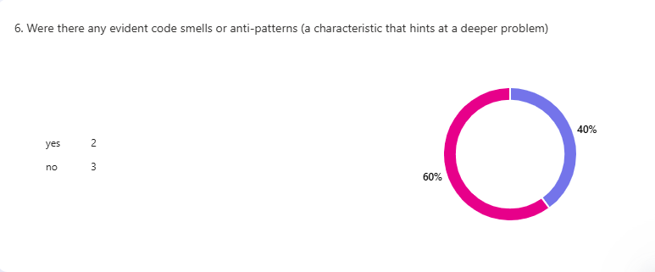
60% of users said no to this question, whilst 40% said yes. With the data being very close, it hints that there may be a code smell that others missed.
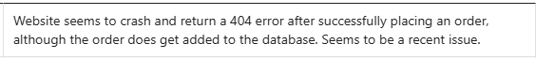
One user left a statement to support their answer (Yes). It describes the 404 error that a lot of users found in the non-technical testing.

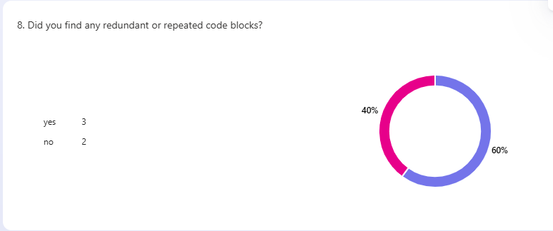
There was a 60% (no), 40% (yes) split for this question. Like the last question, the data is very close to each other. This is quite a close split which could call for a close look at the code to look for redundant code
The feedback left shows that some of the sql statements are repeated/ redundant. It also shows that the database connections are repeated. This is also in need of review.
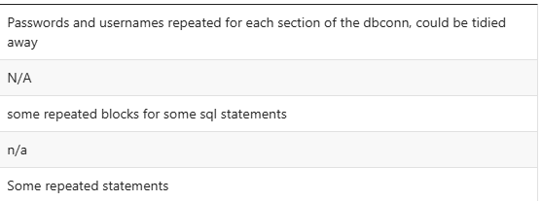

For the rating of the codes quality and structure. The rating averaged 8. All testers chose to rate the overall code quality and structure highly.
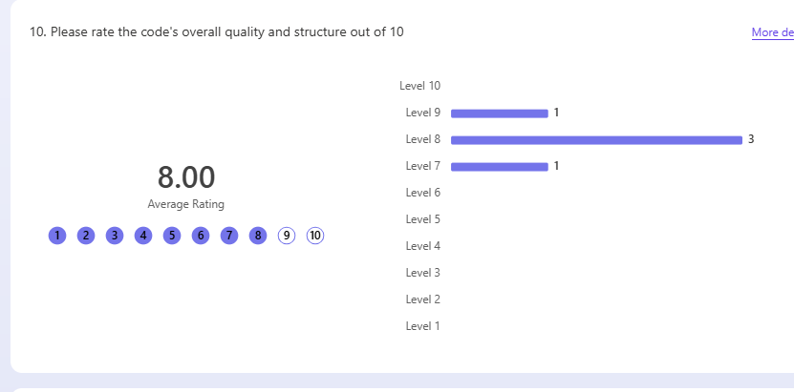
User feedback on question 11 (what went well with the codes quality and structure?) shows that most users found:
- the code is readable and clear
- the code is repeatable
- variable names are clear and make sense
- the code is well structured
- code can handle thrown exceptions well
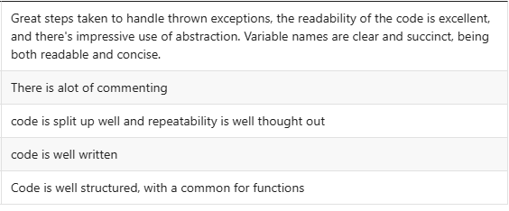

User feedback on question 12 (what went wrong with the codes quality and structure?) shows that most users found:
- there were a few segments of repeating code
- an unfinished block of code in common
- password validation was not considered or implemented
- the code doesn’t have enough error handling
- sensitive data is not properly encrypted

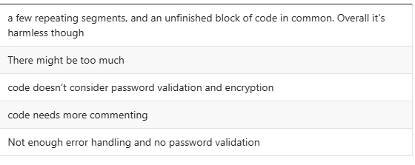
User feedback on question 13 (How would you improve the codes quality and structure?) shows that most users found:
- fixing the 404 error after checkout
- reducing redundant code in certain subroutines
- add more commenting
- add password validation
- add proper error handling
- change HTML to not be echoed out.

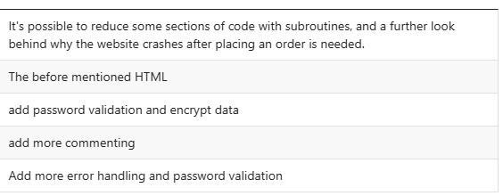

Secure Coding Principals

common security vulnerabilities are properly addressed – 60% of users chose disagree, 40% of users chose agree.

The data is quite close with this one but the majority chose to disagree with the statement which means that the security vulnerabilities are not properly addressed.

user inputs are properly validated and sanitised – 40% of users chose strongly agree, 40% of users chose disagree, 20% of users chose Strongly disagree.

60% of users picked disagree or strongly disagree, this insinuates that the inputs are not properly validated and sanitised. However, All users who agreed chose strongly agree which shows there may be some validation and sanitisation of user inputs.

sensitive data is handled securely (eg encryption, hashing) – 60% of users chose agree, 20% of users chose disagree, 20% of users chose Strongly disagree.

60% of users chose agree for this section, saying that sensitive data is handled securely. However based on the 40% of users that disagreed, 20% strongly disagreeing and past inputs about how the database connection is insecure, It could be considered that the data is not handled securely.

authorisation mechanisms are implemented securely – 60% of users chose disagree, 40% of users chose agree.

The data is a close 60-40 split with the majority saying disagreeing with the statement, this means that the authorisation mechanisms may not be implemented in a secure manner.

Access controls are enforced – 80% of users chose agree, 20% of users chose strongly agree.

80% of users agree that the access controls are properly enforced. This proves that the access controls are securely enforced.

Permissions are checked on the server side, not just the client side – 60% of users chose agree, 20% of users chose strongly agree, 20% of users chose neutral.

80% of users agreed that permissions are properly checked on the server side of the program and not just the server side. The 20% that did not agree remained neutral. This means that the permissions are properly checked.

Security concerns are properly documented in the code - 40% of users chose agree, 40% of users chose disagree, 20% of users chose strongly agree.

60% of users chose to agree with the statements sating that any security concerns are properly commented in the code already.
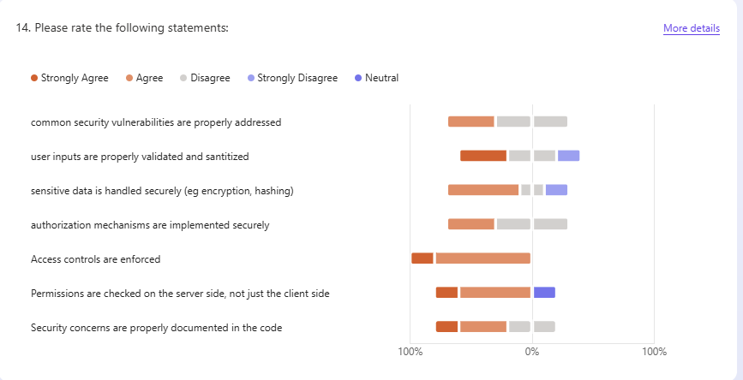
Supporting statements made for this section share that database connections are left insecure in the code (left in plain text) but is addressed in the commenting of the code why this is.
Other comments say that all features are met but not to a high enough standard.
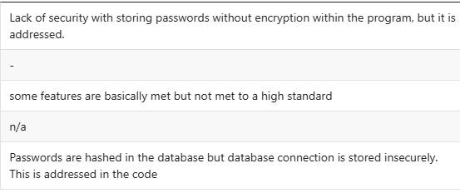

For this question, 80% of users said no to the database credentials being stored securely. This is to be expected based on earlier answers.

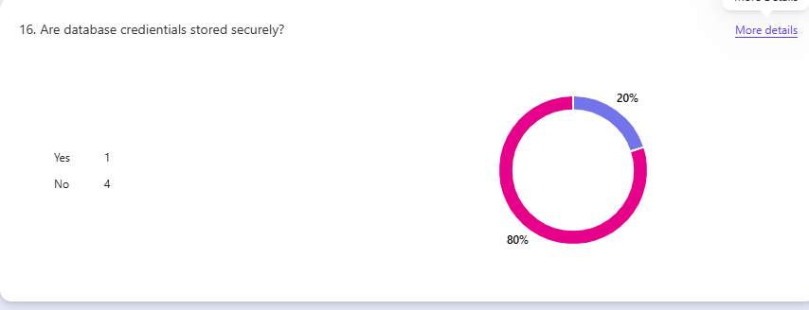
Comments left all state that the database connections are left in plain text instead of being encrypted/hashed. With steps being taken to reduce the potential damage done with these being left in plain text but enough to keep the system secure.
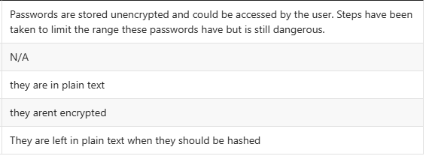
For this question, 40% of users said that dependencies are vetted and up to date whilst 60% said that there are no dependencies present. This could be user error on either part but the data for this is quite confusing.
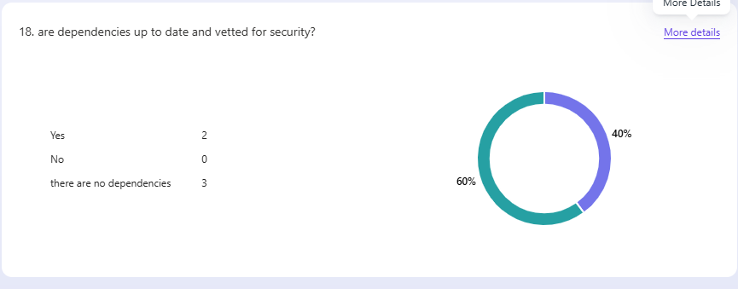
For this section, the average rating is 5.40. This shows that the codes secure coding principals are not highly rated and could use improvement
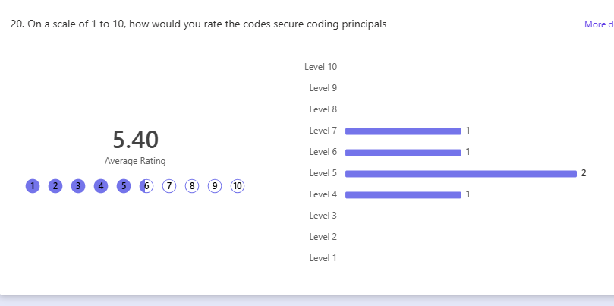

User feedback on question 21 (what went well with the codes secure coding principals?) shows that most users found:
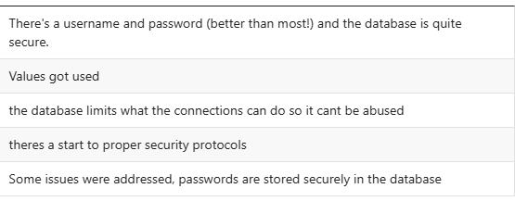
- The username and password needed to connect to the database is secure
- the database limits the connections permissions so it can’t be abused
- Passwords are stored securely in the database
- Some security issues were addressed in the code.

User feedback on question 22 (what went wrong with the codes secure coding principals?) shows that most users found:
- No encryption of database credentials
- incorrect file name on the basket page
- sensitive data is not encrypted properly

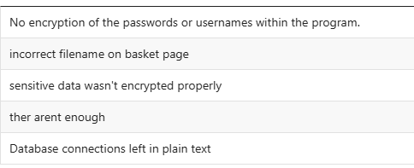

User feedback on question 23 (How would you improve the codes secure coding principals?) shows that most users found they would improve:
- Encryption of passwords/ sensitive data
- Complete more rigorous testing of the system.
- Add password validation
- Make the code more secure against threats
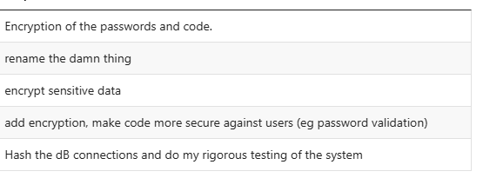

Database and Database Queries

The database is organised to avoid redundancy – 100% of users chose strongly agree.

100% of users strongly agree with the statement. This shows that the database is organised correctly, avoiding redundancy

primary, foreign keys and indexes are used effectively – 80% of users chose agree, 20% of users chose strongly agree.

100% of users agree with the statement. This means that primary, foreign keys and indexes are used effectively in the database.

Naming conventions for tables and columns are consistent and meaningful – 80% of users chose strongly agree, 20% of users chose agree.

100% of users agree with the statement. This means that the naming conventions in the database are well picked and give the data proper meaning.

The database supports future scaleability and performance needs for the system – 40% of users chose agree, 40% of users chose strongly agree, 20% of users chose disagree.

80% of users agree with the statement, meaning that the database meets the performance needs and scaleability needs. 20% of users disagree which could be worth reviewing the database for these factors to see what could be improved.

database permissions are following the principle of least privilege – 60% of users chose agree, 40% of users chose strongly agree.

100% of users agree with the statement. This means that the database permissions follow the principle of least privilege.

Database constraints (eg NOT NULL, UNIQUE etc) are enforced. – 60% of users chose agree, 40% of users chose strongly agree.

100% of users agree with the statement. This means that proper database constraints are met.

The database follows industry standards – 60% of users chose neutral, 20% of users chose strongly agree, 20% of user chose agree.

60% of of users chose to remain neutral on this statement. The other 40% agreed with it. This shows that industry standards are met.

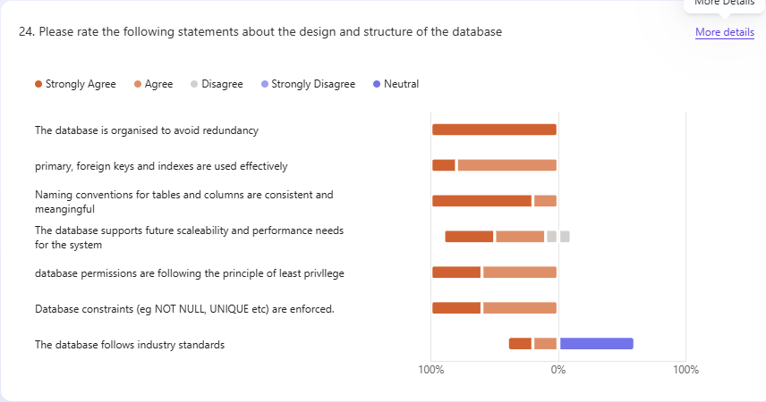
The average rating of the design and structure of the database is 7.20. All users rating over 5 stars, quite highly. This is less then the overall code quality and structure but more then the codes security principals.
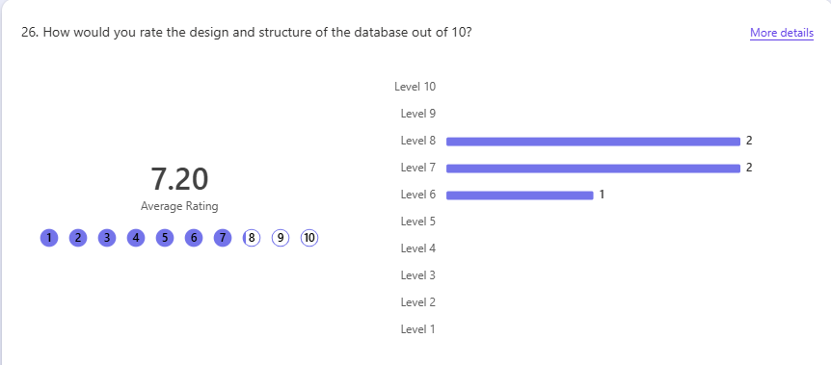

User feedback on question 27 (what went well with the design and structure of the database?) shows that most users found:
- the database is well organised and managed
- the database is designed with little to no redundancy
- database access points have limited access to the system
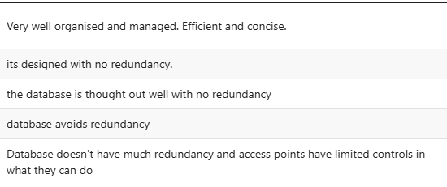
User feedback on question 28 (what went wrong with the design and structure of the database?) shows that most users found:
- the database wasn’t thought out well for future expansion (scalability)
- Database connections are aren’t stored securely
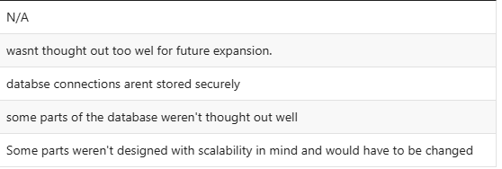

User feedback on question 29 (How would you improve the design and structure of the database?) shows that most users found they would improve:
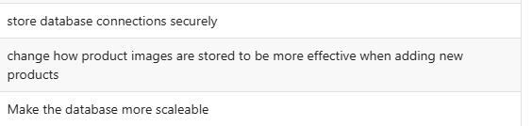
- Database connections
- how product images are stored to be more effective for adding new products
- Make the database more scaleable

queries are optimised for performance – 40% of users chose neutral, 20% of users chose strongly agree, 20% of users chose agree, 20% of users chose disagree.

40% of users chose to remain neutral, 40% of user agreed with the statement, 20% disagreed with the statement. The results are quite mixed. This shows that the queries may be optimised but the testers may not been experienced enough to properly tell.

Prepared statements are parametrised to prevent SQL injection – 60% of users chose agree, 20% of users chose strongly agree, 20% of users chose disagree.

80% of users agree with the statement showing that prepared statements are parametrised.

Database connections are managed efficiently and securely – 40% of users chose agree, 40% of users chose disagree, 20% of users chose strongly disagree.

60% of users chose to disagree with the statement, with previous answers the database connection is not managed I na secure manner

the data is consistent in the database – 60% of users chose agree, 40% of users chose strongly agree.

100% of users agreed with the statement that the data is consistent in the database.

the database complies with relevant regulations and standards (eg GDPR, DPA) – 80% of users chose neutral, 20% of users chose agree.

80% of users remained neutral with the statement that the database complies with relevant regulations and standards. This is because the testing pool consisted of students who aren’t expereicned in the regulations to make a proper decision.

bulk operations are reviewed for unintended side effects – 40% of users chose agree, 20% of users chose strongly agree, 20% of users chose disagree, 20% of users chose neutral.

60% of users agree with the statement that bulk operations are reviewed for side effects. This means that users mostly agree that they are.

failed login attempts are logged and monitored – 60% of users chose strongly disagree, 40% of users chose disagree.

100% of users disagreed with the statement. This means that failed login attempts are not logged or monitored.
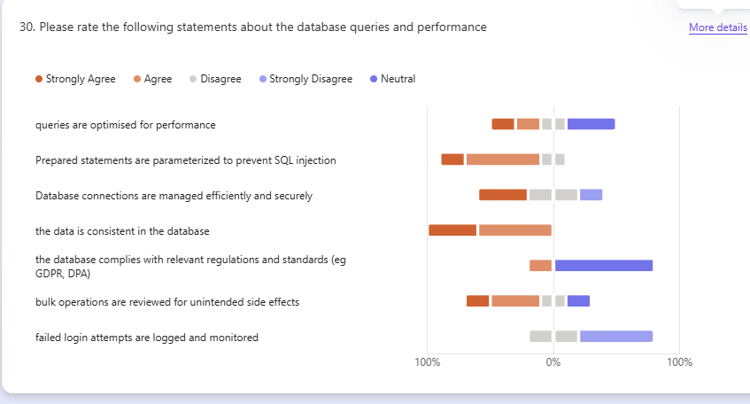

Comments left all state that failed login attempts are not logged in the audit system.

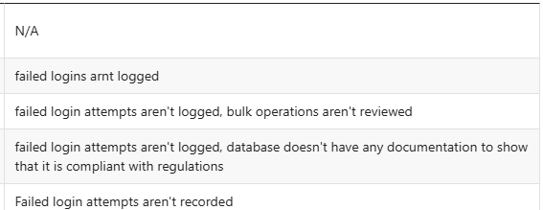

The average rating for the database queries and performance is 6.60, all users voting between 6 and 7 stars. This is lower then the codes overall quality and structure and the design and structure of the database but it higher then the codes security protocols.
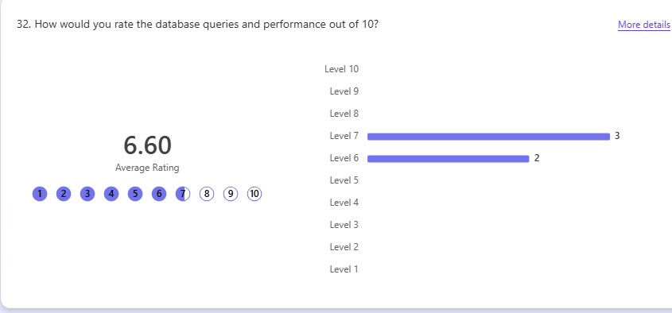

User feedback on question 33 (what went well with the database queries and performance?) shows that most users found:
- All queries worked as intended
- parameter were binded for security
- data is consistent in the database

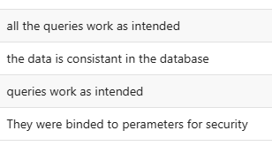

User feedback on question 34 (what went wrong with the database queries and performance?) shows that most users found:
- more data needs auditing (eg failed login attempts)
- documentation is needed for how it complies with legislation.

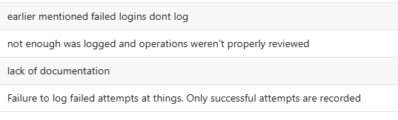

User feedback on question 35 (How would you improve the database queries and performance?) shows that most users found they would improve:
- log failed login attempts
- add proper documentation.
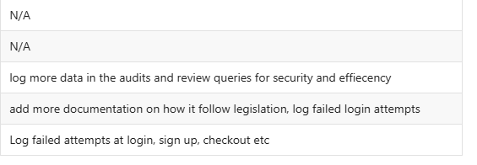

Overall System

there is sufficient documentation for setup, deployment and maintenance of the system – 60% of users chose strongly disagree, 20% of users chose strongly agree, 20% of users chose neutral.

60% of users strongly disagreed with the statement. This shows that there is not a sufficient amount of documentation for the system.

The system has proper logging for debugging and monitoring – 60% of users chose agree, 40% of users chose disagree.

60% of users agreed that the system has proper logging but based on earlier answers and the 40% of users that disagree, There is room for improvement.

there is proper mitigation/ version control for database changes – 40% of users chose neutral, 20% of users chose strongly agree, 20% of users chose agree, 20% of users chose disagree.

40% of users agreed with the statement, 40% remained neutral and 20% disagreed. This mix of answers could show that there is not proper mitigation and version control for database changes.

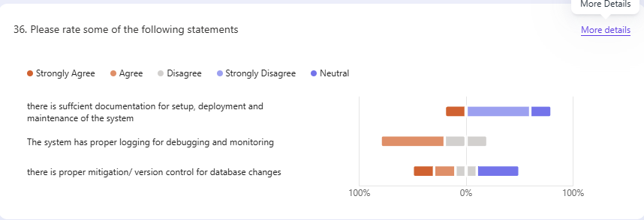
Some comments left share that there is a lack of all the features above and another saying that there is no documentation, some logging but not enough.

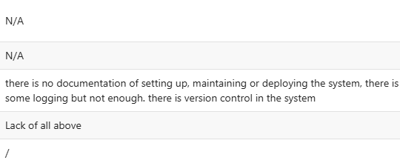
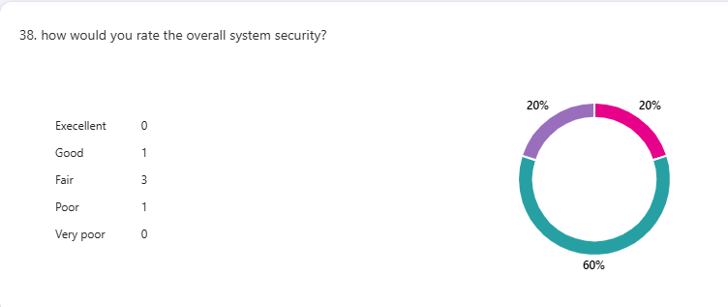
Most users found the overall system security as fair. 1 user found it good and 1 found it poor. These results show that the systems security needs improving.
User feedback on question 39 (What are the largest security risks you identified?) shows that most users found:
- A lack of encryption
- mitigation to breaking system
- database connections are stored in plain text
- failed login attempts aren’t logged
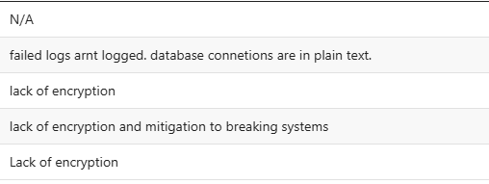

40% of users said that the system would not be able to resist attacks to it. This shows that the security of the system needs improving.
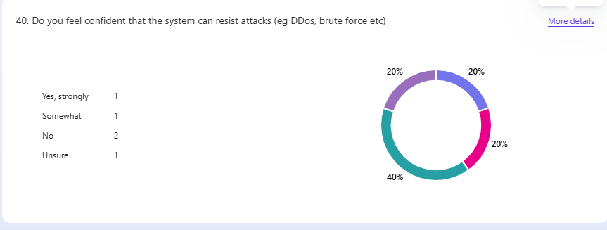

40% of users rated the usability of the system as high and another 40% rated it as low. This data shows it has moderate usability but needs improving.
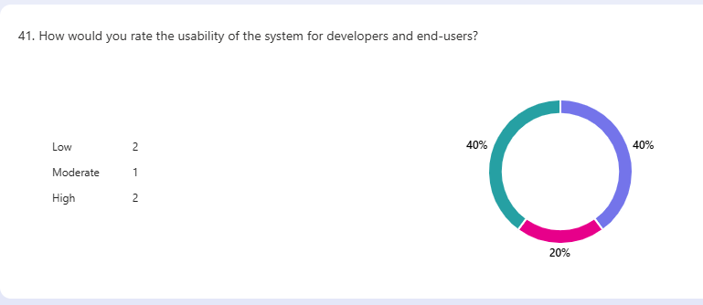
The systems scaleability has the average rating of 6.40. This reflects that the system is moderately scaleable.

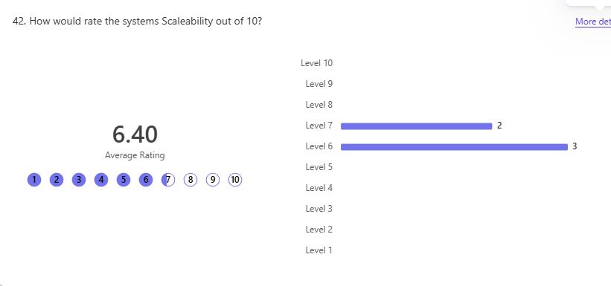
The overall performance of the system was 6.20. This supports that it is a moderately good system with some issues that need resolving.

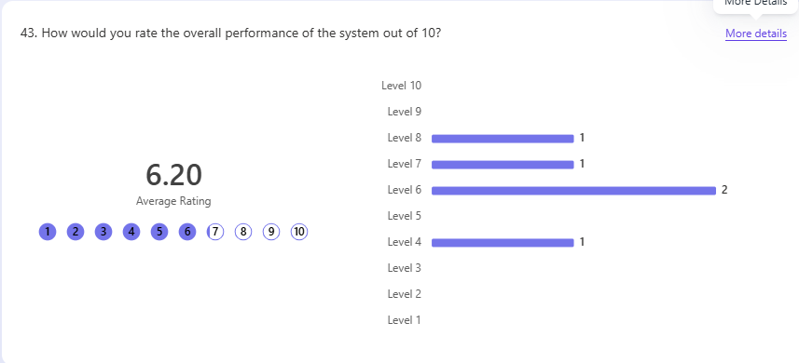
User feedback on question 44 (What went well with the overall system?) shows that most users found:
- the system is functional and works mostly as intended
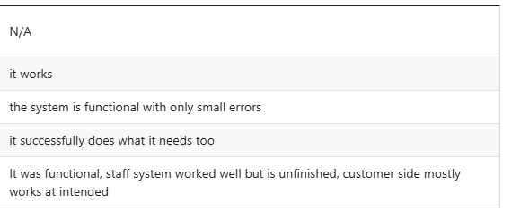

User feedback on question 45 (What went wrong with the overall system?) shows that most users found:
- 404 error on checkout due to an incorrect file name when redirecting
- A lack of css
- lack of security
- lack of proper documentation
- lack of care when reviewing code for mistakes

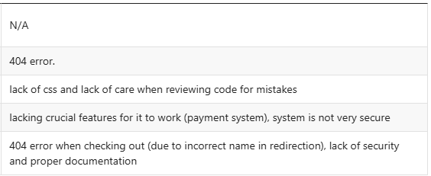

User feedback on question 46 (would you improve the overall system?) shows that most users found:
- Adding a payment option when completing an order
- Improve the CSS
- Review code for mistakes
- Improve system security
- Add content to blank pages
- improve documentation

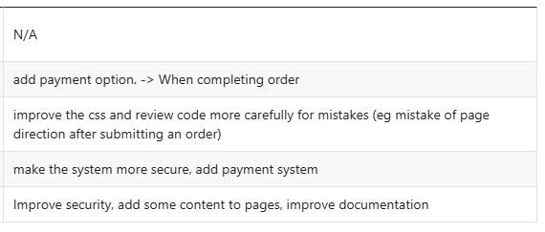

Report Summary

Non-technical Audiences

Key Strengths
During the non-technical feedback, most users agreed that the systems functionality worked as intended. This shows that the system is well designed and works for the majority of users. Users responded well to how the system is made showing its effectiveness for users.
This also means that most users found the system easy to use (see likert scale) and the majority of users could navigate around the website based on its current design.

Areas For Improvement
Most users found one common problem while testing the system. On checkout there was a 404 error after submitting their order. At first, this was shocking to hear as this was not an issue during development. Under further investigation, I discovered that the file name for the redirect that was supposed to take place after the users order was successfully added was incorrect. Luckily this will be a simple and easy fix to make. This does show that the system needs to be looked over more carefully to ensure that no mistakes like this remain in the system before it is released to the public.

Users also found that the styling (CSS) that the system had was not appealing to users and in some cases, made the system harder to use. In the final product this must be used as it made the website seem untrustworthy and not safe to use. This is most likely what led to users giving low ratings on question 21 (average rating 2.74 starts out of 5).
In this modern age, a lack of styling to make a website look professional and real will drastically effect how a website will perform. Especially on e-commerce systems like greenfield local hub, where users are expected to give the system their sensitive data.
Although many users did not bring this up, it is worth noting. Some users found the system inaccessible to their needs. Ensuring the system is accessible to all users is essential to making sure that everyone can use the system. This is due to the styling or lack there of on the website, making some parts of the website hard to find (eg the basket, as users reported struggling to find it). The website does not properly follow the WCAG guidelines on accessibility which can leave the system open to legal troubles due to legislation like the equality act 2010.

Although they failed to write in the form, one user verbally stated that the website was under ‘http’ instead of ‘https’ which meant the connection was not secure, making the webpage as a whole seem less trustworthy and secure. Ptoper measures to make sure the website is under ‘https’ should be made.

Overview
Based on the feedback received, users found the core features of the system easy to use but the styling of the website and some minor errors made the website a lot more difficult to navigate and use successfully. This led to user confusion and frustration when using the system.

Technical audiences

Key Strengths
A key strength most users identified was that the code was well written and had a good amount of commenting to describe the code and what each section does. This is good as it makes the easy to understand for future development and maintaining the system long term. Proper commenting ensures that the solution will be viable for long term usage.

The database connections are designed so that they can only do certain things in the database (eg insert data, select data, update data or delete data). This improves the databases overall security as in the case of a breach to the database, there’s a limit to what they can do, rather then being given complete admin access over the entire thing. It also ensures that queries into the database cannot accidentality do something else then what it intends as the database connection won’t allow it.

In the database, Passwords are properly hashed for security. This ensures that they are stored securely in the database and lessens the likelihood of accounts being hacked/ stolen. It is crucial for the system security that data is encrypted to keep it secure.

The database is well designed with no redundancy in the system. Testers found that the database was well designed and had no redundancy making sure that the data is useful and meaningfully stored in the database. This helps ensure that the database is up to date with proper legislation (GDPR) and can be managed easier without the possibility of repeating data.

The queries to the database work as intended. Queries into the database do what they are designed to do without any negative side effects. The parameters going into the database are also binded for security. Preventing SQL injections.

Areas For Improvement
In the technical feedback, most area that need improving are to do with the systems security. Some are due to the limitations of the development environment (caused by the exam conditions or limits put in place in my schools system). These issues are a lot less likely to occur in a professional development environment.
Other issues (like the lack of CSS and the 404 error on checkout) are addressed in the non-technical feedback review.

An issues some testers addressed was the lack of password validation when signing up for an account. This means that users can set their passwords to be as insecure as they want which leaves their accounts open to being hacked. If password validation was in place, users would be forced to make their passwords certain lengths, include special characters and numbers etc. This would drastically improve the security of user accounts and the system as a whole as users would be a lot less likely to lose their accounts to hacking.

Another thing that was overlooked in the system was auditing failed login attempts to accounts. If they were logged, It would make it a lot easier and clearer to spot when attacks (eg brute force attacks) are taking place. Only successful attempts on the system are being logged which only shows half the story a lot of the time.

Most tester stated that there was a serious lack of encryption in some vital systems of the database (eh the database connections were stored in plain text). The only real encryption of data is that the passwords were hashed before being sent to the database. This was caused by the development environment I had available to me but it still compromises the database to being breached.

The system lacked error handling on certain parts of it. There wasn’t a pre-designed 404 page so it was just blank with “404 error: page not found” in large text. Offering no way for users to go back other then the arrows built into most web browsers. There was also a lack of sanitation and validation of user inputs, which could allow for malicious code to be inputted into the search bar (eg SQL injection).

The database was not designed with future scaleability in mind. This makes the system as a whole less scaleable for future development. This is not ideal for a prototype product as more changes will need to made for changes and other requirements the client needs. It also worsens the maintainability of the system for if/when it needs updating to match any changing legislation, fixing anything that could break etc.

Rating Comparisons
Based on the different sections I had testers give feedback on, The average rating for each section goes as follows with the best at the top and the worst at the bottom:

- Overall code quality and structure – 8.00 stars
- Design and Structure of the Database – 7.20 stars
- Database Queries and Performance – 6.60 stars
- Secure Coding principals – 5.40 stars
This shows that the best feature of the code is its overall quality and structure based on the average ratings. The feedback provided backs this up as users agreed in the data that it is the best made part of the code.
In contrast, the worst part of the code is the secure coding principals. This is shown in the data and based on what users said as most users had issues with the security and encryption of data in the code.
This is important as it displays which section needs the most improvements before it is a deployable standard.

Overview
Overall, Users mainly had issues with the lack of security with the database connection. The connection needs to be improved to make sure that the system is secure and safe. The security of data is top priority as the consequences of not are dire to users and to the company. It will not just lead to major fines based on the Data protection act 2018 but it will also lose the trust of users who will choose to use different services instead.

